Cais Rhyddid Gwybodaeth / Freedom of Information request
Ein Cyf / Our Ref: 25-J-009

You asked:
As I understand it, the health board currently has a recruitment freeze due to its financial difficulties. Saving money is obviously being analysed.
Therefore, I would like more information on how the health board came to a decision to recruit a Band 8d - £89,491 to £103,203 a year per annum – Chief Business O (to support the CEO, Chair and Vice-Chair).
I would like to know the following:
- Is this a new post or a replacement post? and is this a temporary or fixed term post? Please provide a copy of the job description.
I can confirm that it is a new permanent post. Please find attached Appendix 1.
- Please provide a copy of the detailed job vacancy control form as to why the job was required/essential and the relevant risk assessment (if any) completed?
Please see Appendix 2, Appendix 3 and Appendix 4 attached.
- Please provide me with a copy of any notes taken at vacancy control, where it was decided this post was an essential requirement for the health board?
This post was considered and approved at the vacancy control panel held on 16th April 2025. A copy of the vacancy control panel record is as follows:
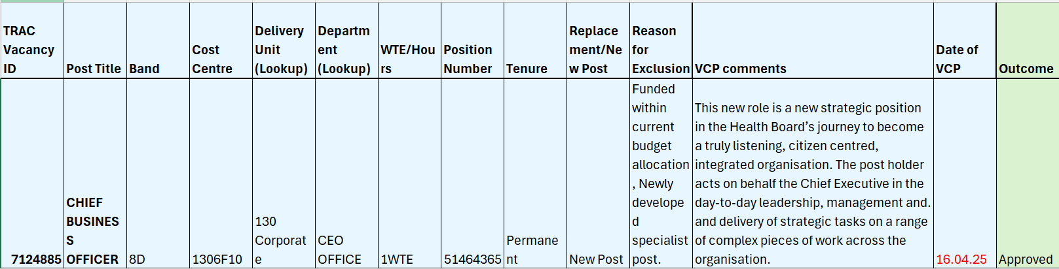

- What budget does this post come out of?
I can confirm that this post is funded by the Corporate Executive Board budget.
- Lastly, explain how you feel public money can be spent in this way, when surely clinical services should be a priority?
The Health Board’s Vacancy Control Process ensures that the appropriate approval is received before jobs are advertised/ filled. Value for public money is considered as part of this process.
_____________________________________________________________

