SBU HB Mortality Information June 2019
This publication provides detail of Mortality rates and other related population indicators for SBU Health Board.
Please note that from 1st April 2019 responsibility for providing healthcare services for people in the Bridgend County Borough Council area transferred from Abertawe Bro Morgannwg University Health Board to Cwm Taf Morgannwg University Health Board. In light of this change to ABMU’s responsibilities, the organisation’s name has changed to Swansea Bay University Health Board. Data in this publication contains historical information prior to 1st April 2019 and as a result will relate to ABMU Health Board which will include Bridgend.
Life Expectancy at birth
In common with England and Wales, life expectancy at birth across the ABMU HB area has continued to increase. Not all our communities share the same life chances; our lifestyles are strongly influenced by the material and social circumstances we find ourselves in. Factors like poverty, deprivation and lifestyle choices (smoking, alcohol, drugs, obesity, physical activity and employment status) influence life expectancy and quality of life.
The chart below shows the average life expectancy for males and females has increased in each of our 3 localities over the last 17 years.
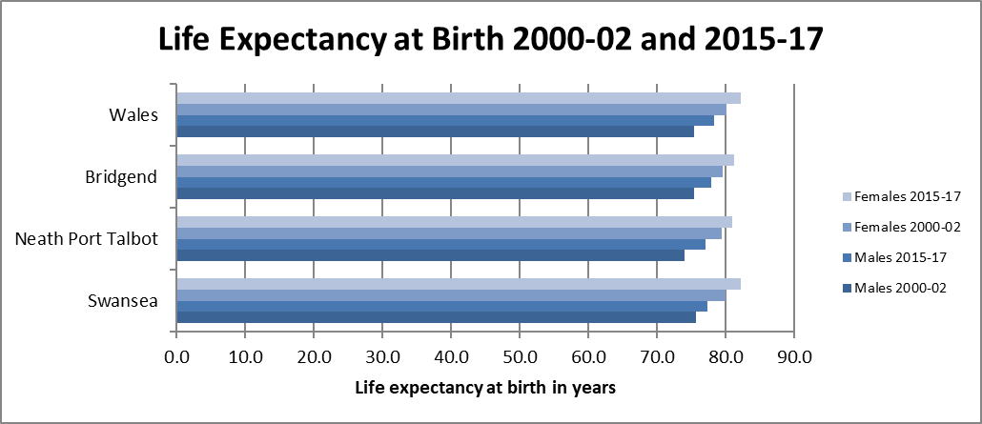

Age Standardised Mortality Rates
The chart below shows the age standardised mortality rate for ABMU areas for males and females.
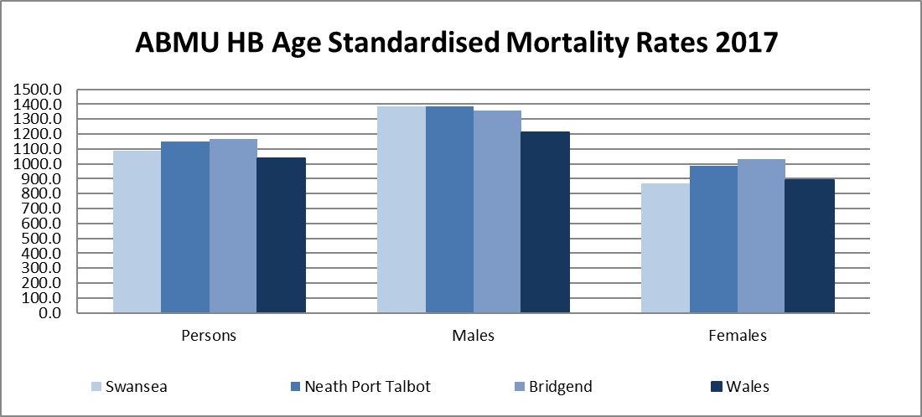
The above rate has now been calculated using the 2013 European Population Standard (ESP), replacing the 1976 ESP standards, which accounts for the significant change in the age standardised rates per 100,000 population when compared to previously reported figures.
Age standardisation takes into account the different age structures of the Health Board’s population. The rates for the Neath Port Talbot and Bridgend localities are slightly higher than the All Wales rates. The rates are expressed per 100,000 population.
Deprivation

Deprivation is measured based on income, employment, health, education, geographical access to service, community safety, physical environment and housing. Wales has some of the highest levels of deprivation and ABMU has more deprived communities than the average for Wales.
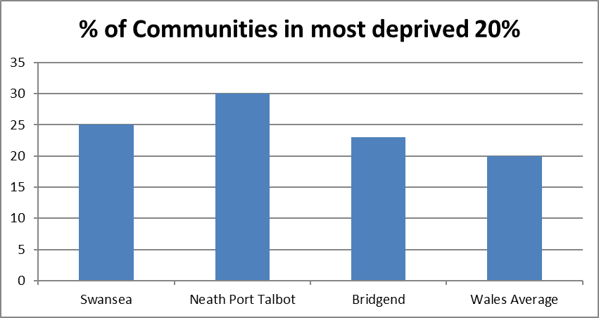
Deprivation is measured in 5 parts ranging from the least to the most deprived. In ABMU over a quarter of our Communities fall into the most deprived category.
Perinatal Mortality
ABMU’s perinatal mortality rate (stillbirths and deaths within first 7 days of life as a rate per 1,000 live and stillbirths) is 6.7, the All Wales average is 6.5.
Excess Winter Deaths
In common with England and the rest of Wales ABMU HB has more deaths in the wintertime period. Whilst some of the excess deaths during a winter period may be due to extreme weather conditions, often it is conditions susceptible to cold temperatures like stroke, heart attack, pneumonia and influenza, which are the main causes. This is why it is important that we keep ourselves warm during the colder months and try to protect our most vulnerable citizens, ensuring they are vaccinated against that winter’s strain of influenza.
In the winter period of 2016/17 the number of excess winter deaths was only slightly higher than 2015/2016 despite a reduction in the average temperature for the period. Excess winter deaths increased in Swansea but reduced in NPT and Bridgend.
Area | 2005-06 | 2006-07 | 2007-08 | 2008-09 | 2009-10 | 2010-11 | 2011-12 | 2012-13 | 2013-14 | 2014-15 | 2015-16 | 2016-17
Swansea | 15.0 | 20.7 | 8.9 | 25.4 | 21.9 | 14.6 | 12.5 | 15.1 | 13.4 | 28.2 | 19.2 | 21.2
Neath Port Talbot | 8.5 | 18.3 | 0.9 | 27.7 | 23.4 | 33.1 | 8.3 | 18.9 | 1.7 | 21.9 | 24.4 | 9.9
Bridgend | 19.4 | -5.1 | 15.8 | 22.2 | 21.1 | 36.4 | 24.5 | 11.9 | 14.5 | 34.0 | 16.0 | 14.2
Wales | 15.8 | 14.1 | 14.3 | 25.4 | 17.5 | 20.4 | 12.8 | 18.1 | 10.3 | 25.1 | 17.4 | 17.7
Wales average winter temp | 4.08 | 6.05 | 5.45 | 3.42 | 2.21 | 2.80 | 5.27 | 3.87 | 5.71 | 4.43 | 6.40 | 5.47
The method for calculating this measure defines the winter period as December to March, and compares the number of deaths that occurred in this winter period with the number of deaths in the months prior and following the winter period.
Source: Office for National Statistics
Avoidable Mortality
Avoidable deaths are all those defined as
- Preventable :-
All or most deaths from that cause could be avoided through public health intervention. E.g. Smoking related deaths.
- Amenable :-
All or most deaths from that cause could be avoided through good quality healthcare. E.g. Asthma.
The table below shows the most recently available ONS (Office of National Statistics) data on avoidable deaths.
Causes of death considered avoidable, amenable & preventable, European age-standardised rate (EASR) per 100,000 person, Abertawe Bro Morgannwg UHB, 2014-2017.

 | Avoidable |  |  |  | Amenable |  |  |  | Preventable
 | Count | EASR (95% confidence Intervals) |  |  | Count | EASR (95% confidence Intervals) |  |  | Count | EASR (95% confidence Intervals)
2014 | 1,323 | 257 | (243-271) |  | 734 | 143 | (133-153) |  | 1,109 | 216 | (203-228)
2015 | 1,432 | 277 | (263-291) |  | 774 | 149 | (139-160) |  | 1,211 | 234 | (221-247)
2016 | 1,448 | 277 | (263-291) |  | 756 | 144 | (134-154) |  | 1,233 | 236 | (223-249)
2017 | 1,464 | 277 | (263-291) |  | 747 | 140 | (130-150) |  | 1,268 | 240 | (227-254)

This shows that the calculated rate of deaths considered avoidable (which is shown as an age-standardised rate per 100,000 people) The All Wales average is 249.
It should be noted that the above is a statistical calculation based on analysis of the cause of death on the Death certificate and is not based on specific in depth reviews on individual deaths.
At ABMU, all in hospital deaths form part of a 2 stage review process (as outlined previously).
Mortality Information
When considering all mortality rates it is important to recognise that actual number of patients dying in our hospitals has in fact reduced over time. During 2017, 51% of our deaths occurred in Hospital, which has reduced from 55% in 2012. In addition, 10% of our hospital deaths occur in our two NHS hospices.
Percentage of deaths by place of occurrence 2017
LHB Area | Home | Care Home |  | Hospices |  | Hospitals (acute or  community not  psychiatric) |  | Other  communal  establishments | Elsewhere
LHB Area | Home | Local  Authority | Non-Local  Authority | NHS | Non-NHS | NHS | Non-NHS | Other  communal  establishments | Elsewhere
Betsi Cadwaladr | 22.5% | 1.0% | 17.4% | 0.0% | 4.3% | 52.0% | 0.2% | 0.2% | 2.5%
Powys Teaching | 26.7% | 3.7% | 14.5% | 0.0% | 2.3% | 50.5% | 0.1% | 0.1% | 2.3%
Hywel Dda | 28.3% | 2.0% | 16.9% | 0.0% | 1.1% | 49.1% | 0.0% | 0.2% | 2.5%
ABMU | 23.5% | 0.8% | 15.1% | 0.1% | 0.1% | 57.3% (51.2%) | 0.0% | 0.8% | 1.9%
Cwm Taf | 23.6% | 0.8% | 10.9% | 2.0% | 0.1% | 60.6% | 0.0% | 0.0% | 2.0%
Aneurin Bevan | 25.5% | 0.8% | 14.1% | 0.0% | 1.5% | 56.0% | 0.0% | 0.2% | 1.8%
C & V | 22.0% | 0.3% | 14.6% | 0.1% | 7.0% | 54.0% | 0.0% | 0.0% | 1.9%
Wales | 24.3% | 1.1% | 15.2% | 0.2% | 2.4% | 54.4% | 0.0% | 0.2% | 2.1%
The above table shows that around 51% (3,036) of our population die in hospital compared to 54% (18,075) for Wales and 46.11% (230,015) for England.

In-hospital Mortality
During the rolling 12 month period to March 2019 on average 256 people died in our hospitals per month. This is not statistically different from the previous period (261 for the previous period).

Crude Rates
The crude rate for a site will be affected by not only the number of deaths but also by the number of admissions at a particular site. The rate shown is the actual number of deaths as a percentage of the total patients admitted. The Health Board rate is 1.71%. Below the Princess of Wales chart demonstrates how a change in process has affected the mortality rate.
We monitor the actual number of deaths at all our hospital sites on a monthly basis. This gives an early opportunity to investigate changes in the number of in-hospital deaths.
The crude mortality rates for the Health Board:
Rolling 12 Month
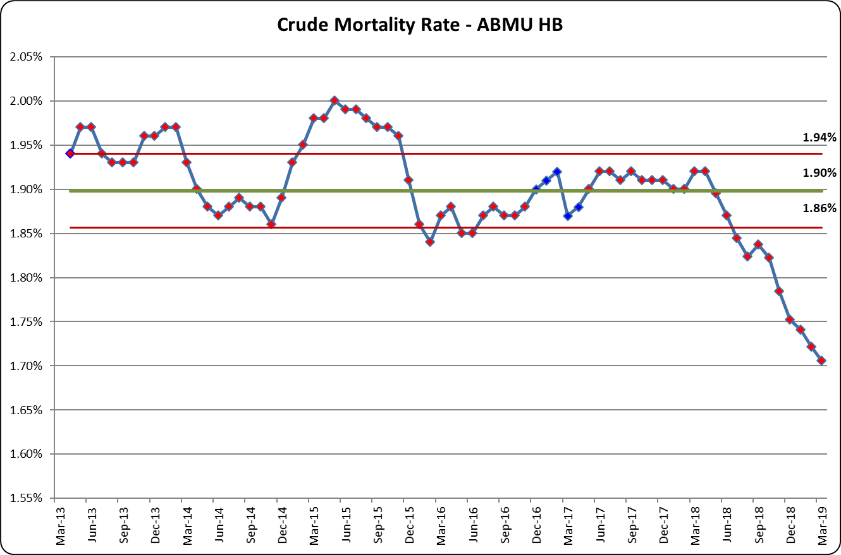
Monthly
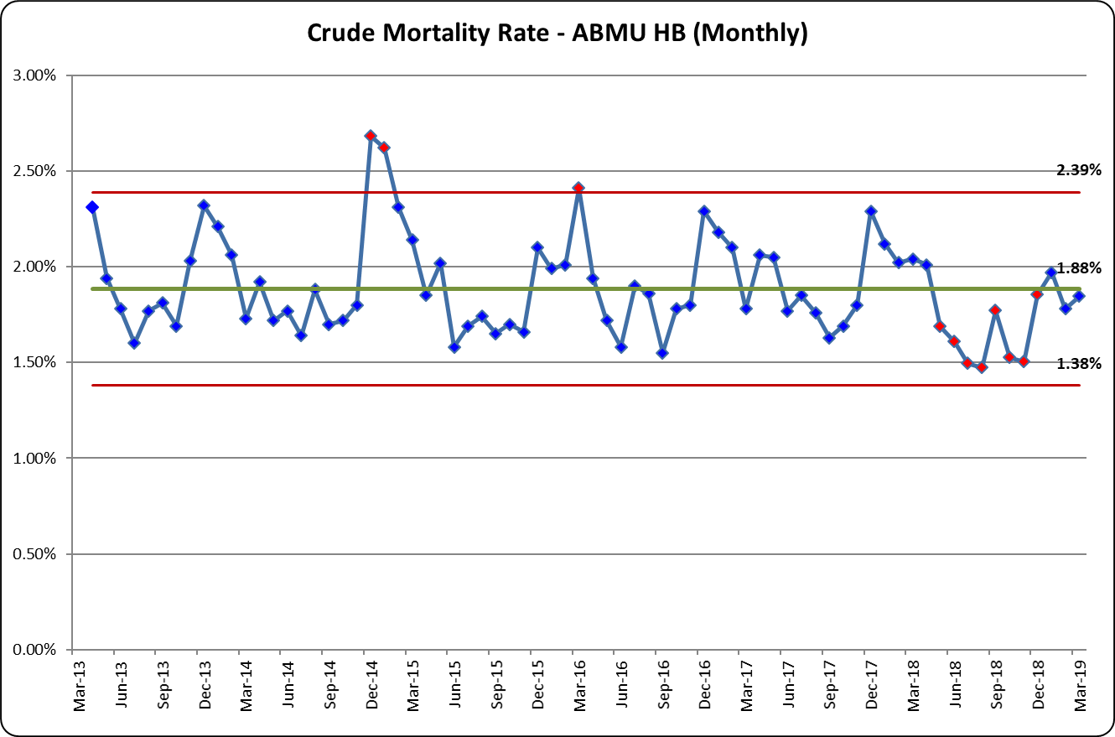
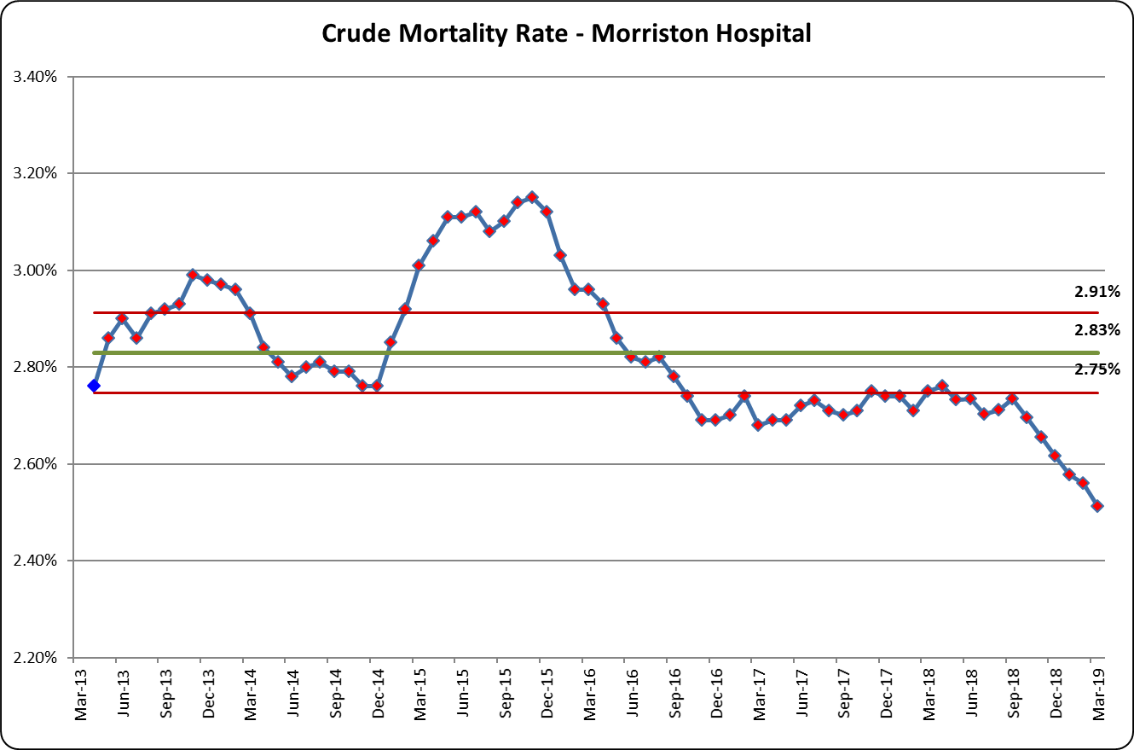
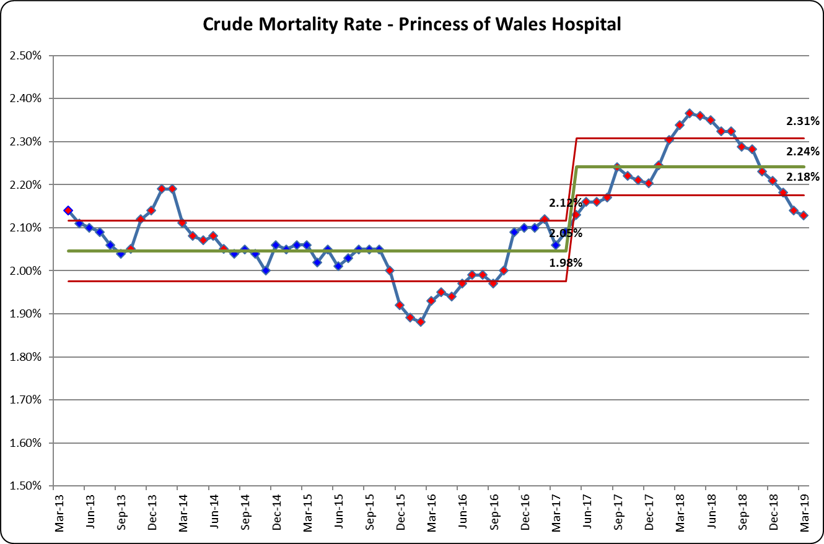
Change in process
In line with the rest of the Health Board, Dermatology activity at Princess of Wales was reclassified to outpatient activity in May 2017, lowering the number of admissions and subsequently inflating the mortality rate. The actual number of deaths has not increased in this period.
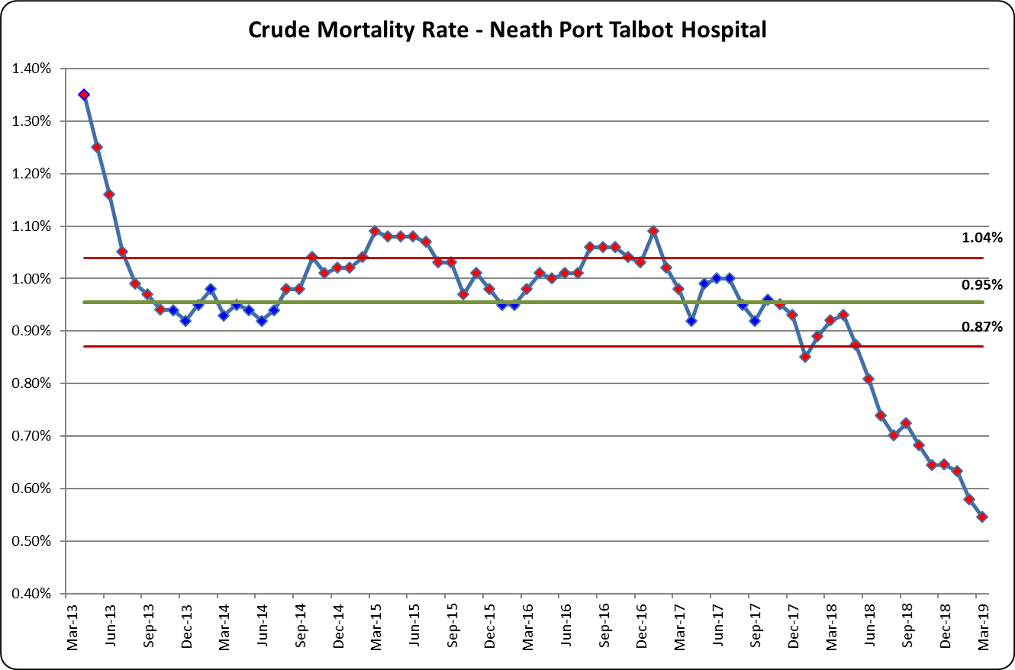
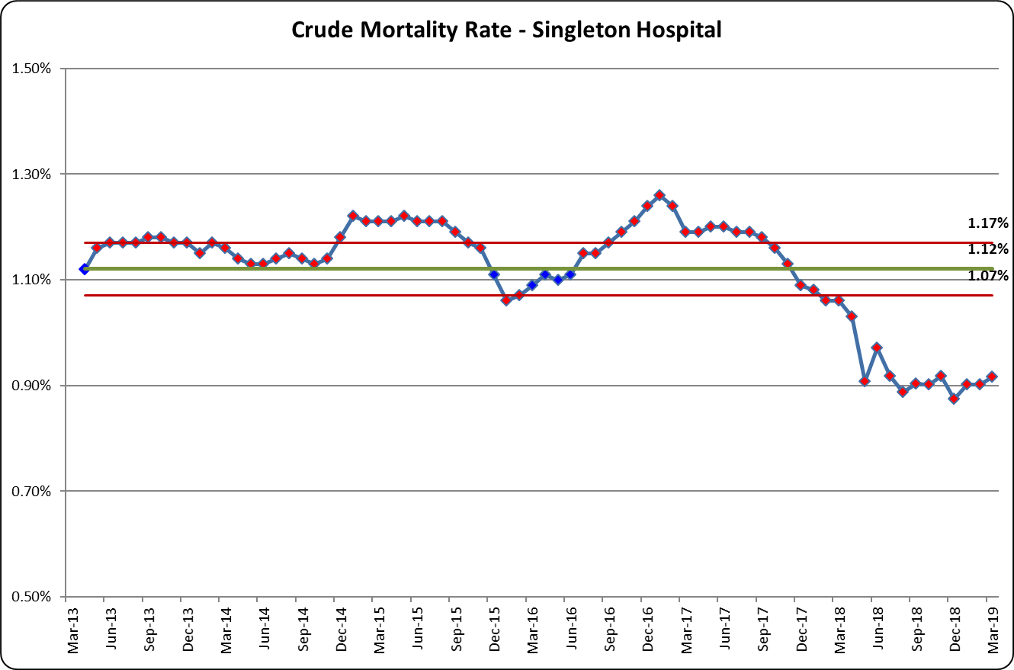

Condition Specific
These measures focus on the deaths within 30 days of admission for 3 specific conditions with well-defined clinical pathways.
Hip Fracture
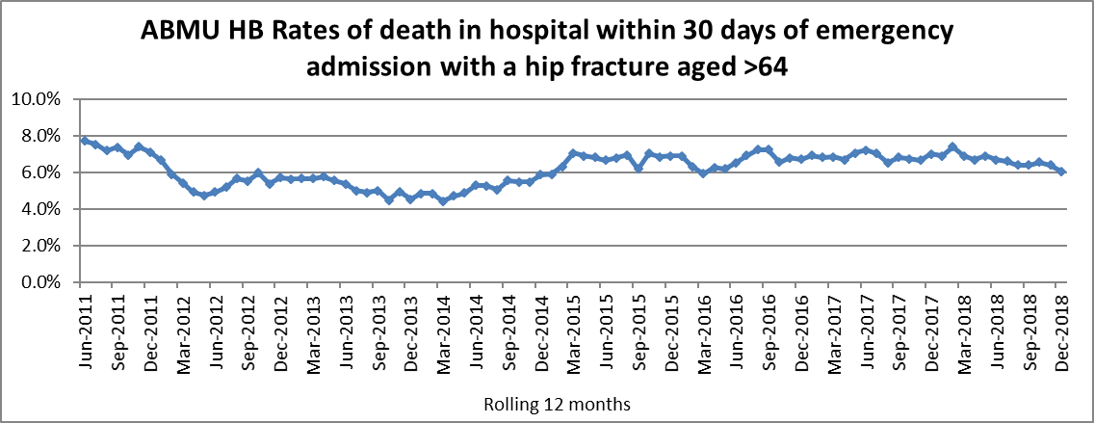
The Health Board rate of death in hospital within 30 days of emergency admission with a hip fracture for patients over the age of 64 is 6.1% for the rolling 12 months to December 2018, which is higher than the Welsh average (5.1%). The Health Board are exploring options to continue to make improvements to the broken hip (“Fracture Neck of Femur”) pathway and further reduce mortality figures by ensuring there is comprehensive geriatric cover for this elderly and frail patient population. We continue to improve the "falls" pathway.

Heart Attack
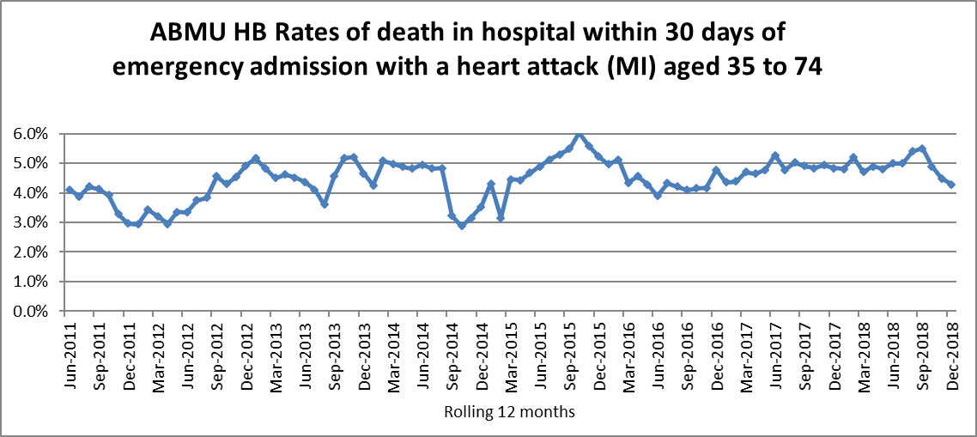
The Health Board rate of death in hospital within 30 days of emergency admission with a heart attack (MI) aged 35 to 74 is 4.3% for the rolling 12 months to December 2018, which is higher than the Welsh average of 3.6%.
In Wales, patients who are having heart attacks are transferred directly from the community to a ‘heart attack centre’ so that they can receive emergency treatment (called primary angioplasty) for a life-threatening condition. Multiple studies conducted in many countries have indicated that this results in the best overall outcome for patients.
Patients admitted to the University Hospital of Wales and to Morriston Hospital have the higher mortality rates overall because these two hospitals have the “heart attack centres” and receive and manage the sickest of these patients from the whole of South Wales. Several of the patients who arrived at Morriston Hospital were in severe cardiogenic shock (failure of the pumping action of the heart) on arrival at hospital. Such patients have an expected survival of less than 50% unless specialist treatment is provided. Those hospitals that no longer provide emergency treatment for heart attacks will be expected to have lower mortality rates since the remaining population will be less sick and therefore at much lower risk of dying.
Those highest risk patients (with cardiogenic shock) have been included in the overall figures presented, so these figures need to be interpreted with caution.
Stroke
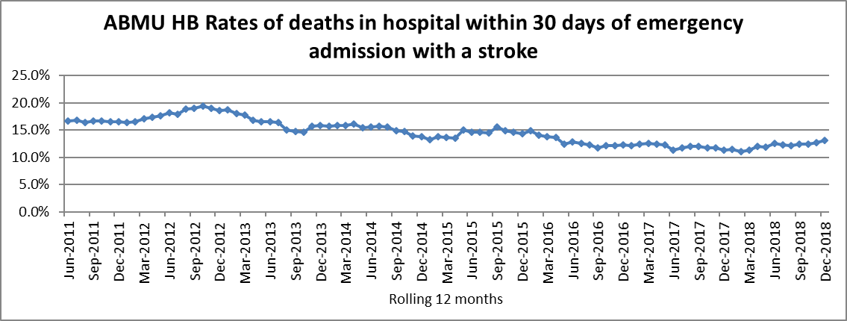
The Health Board rate of deaths in hospital within 30 days of emergency admission with a stroke is 13.1% for the rolling 12 months to December 2018, the Welsh average is 13.2%.
A multi-disciplinary group of specialist stroke doctors, clinical nurse specialists, therapists, psychologists and managers within the Health Board meets regularly with the aim of continually improving the delivery of stroke services through increased compliance with stroke standards across the stroke pathway. The team has redesigned stroke services to ensure consistent delivery of best practice care including giving clot busting drugs. As a result of patients receiving faster and effective care, many more patients are regaining good quality, independent lives following a stroke.
Rates of deaths within 30 days of surgery
These measures focus on the patients who died in hospital within 30 days of a surgical procedure.
Elective Surgery
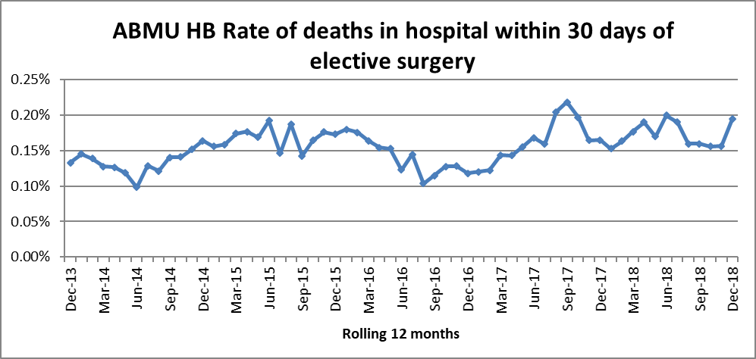
The rate of deaths within 30 days for elective surgery cases for ABMU HB is 0.19%, the All Wales average is 0.12%. Whilst the number of elective surgery deaths is very low the higher rate at ABMU will reflect the fact that Morriston hospital is a centre for many high risk, complex surgical cases. In the time period January 2018 to December 2018 there were 16 elective surgical deaths within 30 days of surgery from more than 8,000 cases.
Emergency Surgery
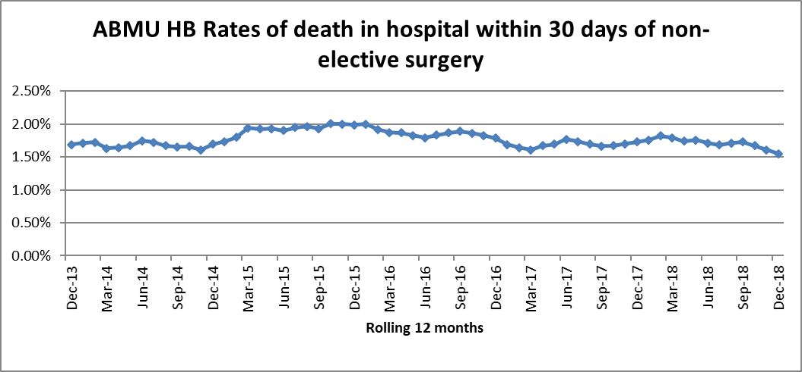
The rate of deaths within 30 days for emergency surgery cases for ABMU HB is 1.55%, the All Wales average is 1.53%. It should be noted that Morriston hospital is the major trauma centre for South West Wales and accepts emergencies into its tertiary services from neighbouring Health Boards.
Accident & Emergency (Major Units) Crude Mortality Rates
The table below show the rolling 12 month crude mortality rate for all Welsh Health Board sites with a major Emergency Department calculated as a rate per 10,000 attendances.

Rolling Annual Period | Wales | Bronglais | Glangwili | Morriston | Nevill Hall | Prince Charles | Princess Of Wales | Royal Gwent | Royal Glamorgan | UHW | Withybush | Wrexham Maelor | Ysbyty Glan Clwyd | Ysbyty Gwynedd
Apr-2012 | 17.4 | 11.4 | 13.7 | 17.0 | 15.4 | 32.1 | 14.1 | 23.1 | 13.1 | 20.6 | 14.3 | 10.8 | 15.7 | 15.1
May-2012 | 17.4 | 11.0 | 13.5 | 16.8 | 15.8 | 30.7 | 14.8 | 23.6 | 13.5 | 20.5 | 13.9 | 10.8 | 16.3 | 14.7
Jun-2012 | 17.6 | 11.3 | 13.1 | 18.1 | 16.8 | 30.0 | 16.0 | 23.0 | 13.5 | 20.6 | 12.9 | 10.7 | 16.6 | 14.8
Jul-2012 | 18.0 | 11.3 | 12.8 | 18.6 | 17.5 | 28.9 | 15.6 | 25.3 | 13.9 | 20.6 | 12.6 | 11.2 | 18.4 | 15.0
Aug-2012 | 18.0 | 11.7 | 13.9 | 18.8 | 17.3 | 27.8 | 15.0 | 26.0 | 14.1 | 19.7 | 13.1 | 11.7 | 19.9 | 13.9
Sep-2012 | 18.4 | 10.6 | 15.5 | 19.5 | 16.2 | 28.0 | 14.8 | 27.2 | 14.3 | 20.3 | 13.6 | 11.9 | 20.1 | 13.9
Oct-2012 | 18.6 | 10.2 | 16.2 | 19.0 | 16.4 | 26.2 | 16.2 | 28.0 | 15.4 | 20.9 | 13.4 | 12.2 | 19.9 | 13.7
Nov-2012 | 18.7 | 8.3 | 14.9 | 18.8 | 16.7 | 25.2 | 17.4 | 27.4 | 16.2 | 21.5 | 14.3 | 12.4 | 19.8 | 14.8
Dec-2012 | 19.0 | 8.7 | 16.4 | 20.4 | 16.2 | 23.1 | 17.8 | 27.6 | 16.5 | 21.1 | 14.2 | 14.1 | 21.2 | 14.3
Jan-2013 | 19.5 | 7.4 | 17.2 | 20.3 | 17.2 | 22.0 | 18.6 | 28.8 | 17.1 | 21.1 | 14.5 | 14.4 | 22.8 | 15.9
Feb-2013 | 19.2 | 7.4 | 17.4 | 20.9 | 15.3 | 21.0 | 17.6 | 28.1 | 17.2 | 20.5 | 14.2 | 14.0 | 23.7 | 17.5
Mar-2013 | 20.0 | 7.9 | 17.4 | 22.7 | 15.5 | 20.7 | 18.4 | 28.5 | 18.7 | 21.2 | 15.0 | 15.2 | 24.4 | 18.2
Apr-2013 | 20.4 | 8.8 | 18.0 | 24.1 | 17.2 | 21.5 | 18.4 | 27.4 | 18.3 | 20.9 | 15.0 | 15.6 | 27.0 | 18.2
May-2013 | 20.6 | 9.6 | 18.6 | 25.5 | 17.2 | 21.4 | 18.8 | 27.5 | 17.6 | 20.8 | 15.2 | 15.7 | 27.8 | 17.6
Jun-2013 | 20.6 | 9.3 | 18.3 | 26.0 | 16.4 | 20.7 | 19.2 | 27.3 | 17.4 | 20.7 | 15.2 | 16.1 | 27.6 | 18.1
Jul-2013 | 20.5 | 9.6 | 18.5 | 25.9 | 17.1 | 22.0 | 19.7 | 25.7 | 16.7 | 21.5 | 14.5 | 16.4 | 26.0 | 18.4
Aug-2013 | 20.4 | 9.2 | 17.7 | 25.6 | 16.4 | 21.3 | 20.3 | 26.3 | 17.5 | 21.5 | 14.4 | 16.1 | 25.6 | 17.3
Sep-2013 | 20.3 | 9.6 | 16.8 | 26.0 | 16.4 | 21.8 | 20.1 | 25.1 | 18.0 | 21.2 | 14.4 | 16.6 | 24.8 | 17.8
Oct-2013 | 20.1 | 9.6 | 16.4 | 26.4 | 15.9 | 21.5 | 19.5 | 24.4 | 17.7 | 20.6 | 15.7 | 16.2 | 24.6 | 18.4
Nov-2013 | 20.0 | 9.6 | 17.0 | 26.4 | 15.5 | 21.9 | 19.1 | 23.4 | 17.1 | 20.8 | 16.1 | 16.1 | 25.3 | 17.3
Dec-2013 | 19.8 | 9.2 | 14.4 | 26.9 | 16.3 | 21.6 | 18.8 | 21.7 | 18.1 | 21.6 | 16.5 | 14.8 | 24.7 | 16.7
Jan-2014 | 19.2 | 9.2 | 13.6 | 26.0 | 17.5 | 20.7 | 18.3 | 19.8 | 18.6 | 20.7 | 16.4 | 15.1 | 23.9 | 16.4
Feb-2014 | 19.5 | 9.3 | 13.7 | 25.7 | 18.4 | 20.3 | 19.2 | 20.1 | 18.8 | 21.4 | 17.4 | 15.7 | 24.2 | 14.9
Mar-2014 | 18.9 | 9.7 | 14.3 | 24.9 | 17.6 | 18.6 | 19.1 | 19.6 | 17.0 | 20.6 | 17.1 | 15.5 | 24.5 | 14.2
Apr-2014 | 18.4 | 8.3 | 13.8 | 23.6 | 16.8 | 17.2 | 19.1 | 19.7 | 16.9 | 20.5 | 18.5 | 15.4 | 22.3 | 13.5
May-2014 | 18.2 | 7.9 | 14.0 | 22.8 | 16.5 | 17.2 | 18.4 | 19.3 | 16.9 | 20.5 | 19.4 | 15.5 | 21.2 | 14.4
Jun-2014 | 18.1 | 8.3 | 14.1 | 21.8 | 16.2 | 17.7 | 18.2 | 19.9 | 17.3 | 20.4 | 19.8 | 15.3 | 20.3 | 14.0
Jul-2014 | 18.2 | 7.8 | 14.4 | 21.9 | 16.1 | 17.9 | 19.1 | 19.4 | 17.8 | 20.2 | 19.7 | 15.2 | 21.5 | 14.0
Aug-2014 | 18.5 | 9.0 | 14.4 | 21.7 | 16.8 | 20.0 | 19.6 | 18.6 | 16.7 | 21.3 | 19.1 | 14.9 | 21.8 | 14.3
Sep-2014 | 18.4 | 9.0 | 13.0 | 21.4 | 17.0 | 20.0 | 20.3 | 18.8 | 15.4 | 21.3 | 18.9 | 14.7 | 23.9 | 13.3
Oct-2014 | 18.7 | 9.3 | 13.5 | 21.7 | 17.4 | 20.9 | 20.6 | 19.3 | 15.7 | 21.3 | 18.8 | 15.3 | 24.8 | 12.6
Nov-2014 | 18.9 | 10.5 | 13.6 | 23.9 | 17.5 | 20.1 | 19.7 | 19.8 | 15.4 | 21.9 | 18.3 | 14.7 | 23.7 | 13.5
Dec-2014 | 19.2 | 10.4 | 15.4 | 23.8 | 16.4 | 21.3 | 20.0 | 20.4 | 15.5 | 20.7 | 17.1 | 16.3 | 27.1 | 14.3
Jan-2015 | 20.4 | 11.5 | 16.5 | 26.0 | 16.1 | 22.0 | 22.7 | 22.2 | 15.4 | 21.6 | 19.1 | 17.0 | 29.4 | 13.7
Feb-2015 | 20.6 | 12.2 | 16.2 | 26.1 | 16.6 | 22.1 | 23.4 | 22.1 | 15.0 | 21.5 | 20.1 | 18.3 | 28.6 | 13.9
Mar-2015 | 20.8 | 11.5 | 14.9 | 27.6 | 18.0 | 23.4 | 23.3 | 21.9 | 15.7 | 21.1 | 19.8 | 18.1 | 29.1 | 14.5
Apr-2015 | 21.1 | 12.2 | 15.1 | 28.0 | 18.4 | 24.3 | 23.4 | 21.7 | 16.1 | 21.0 | 18.4 | 19.0 | 30.4 | 15.4
May-2015 | 21.7 | 12.5 | 15.6 | 29.0 | 19.1 | 26.1 | 23.9 | 22.4 | 17.0 | 21.5 | 17.0 | 20.2 | 31.6 | 14.6
Jun-2015 | 21.9 | 12.1 | 16.1 | 29.6 | 20.0 | 26.3 | 24.0 | 21.7 | 16.5 | 21.2 | 17.6 | 21.2 | 33.2 | 14.7
Jul-2015 | 21.8 | 11.3 | 15.2 | 29.5 | 19.2 | 25.0 | 23.6 | 21.9 | 16.6 | 21.0 | 17.9 | 21.6 | 32.9 | 15.1
Aug-2015 | 21.6 | 10.5 | 16.2 | 30.4 | 18.7 | 22.9 | 23.1 | 21.8 | 17.0 | 20.9 | 19.5 | 22.1 | 31.4 | 14.3
Sep-2015 | 21.4 | 10.9 | 16.7 | 30.1 | 18.4 | 21.8 | 21.7 | 22.2 | 17.9 | 20.7 | 18.6 | 22.6 | 29.6 | 15.5
Oct-2015 | 21.4 | 10.8 | 17.4 | 30.2 | 18.1 | 22.2 | 22.0 | 21.9 | 16.7 | 21.3 | 18.1 | 21.5 | 30.2 | 15.2
Nov-2015 | 21.2 | 10.0 | 17.1 | 28.1 | 19.7 | 23.3 | 22.4 | 22.2 | 16.5 | 19.4 | 17.9 | 22.8 | 31.5 | 14.4
Dec-2015 | 20.6 | 11.5 | 17.6 | 27.7 | 19.1 | 21.5 | 23.0 | 22.7 | 15.0 | 19.5 | 18.7 | 20.5 | 28.6 | 13.8
Jan-2016 | 19.8 | 10.6 | 17.6 | 27.7 | 17.8 | 21.0 | 19.5 | 21.5 | 15.1 | 19.3 | 16.1 | 20.1 | 26.7 | 13.7
Feb-2016 | 19.7 | 11.3 | 17.6 | 28.6 | 16.8 | 20.8 | 18.1 | 22.1 | 15.4 | 19.2 | 14.7 | 19.3 | 27.3 | 13.0
Mar-2016 | 19.6 | 10.8 | 18.7 | 28.6 | 16.7 | 19.4 | 17.8 | 23.1 | 15.2 | 19.5 | 14.9 | 18.6 | 27.6 | 11.5
Apr-2016 | 19.8 | 10.8 | 20.3 | 30.3 | 16.4 | 18.9 | 17.3 | 23.6 | 15.2 | 19.2 | 14.7 | 18.9 | 26.9 | 11.3
May-2016 | 19.4 | 10.3 | 20.3 | 30.0 | 17.2 | 17.9 | 16.8 | 22.6 | 14.7 | 19.0 | 14.9 | 17.7 | 28.2 | 11.1
Jun-2016 | 18.9 | 10.6 | 19.4 | 28.6 | 16.1 | 17.4 | 16.3 | 22.6 | 14.6 | 18.9 | 13.6 | 17.0 | 27.8 | 10.1
Jul-2016 | 19.0 | 10.2 | 20.5 | 28.9 | 16.7 | 17.2 | 16.4 | 22.3 | 14.6 | 18.3 | 13.6 | 17.5 | 27.0 | 11.1
Aug-2016 | 19.1 | 10.1 | 19.6 | 28.8 | 18.1 | 17.8 | 15.4 | 23.4 | 14.3 | 17.9 | 12.3 | 18.1 | 29.1 | 11.9
Sep-2016 | 19.2 | 9.7 | 19.2 | 28.8 | 18.1 | 18.8 | 16.2 | 23.1 | 13.7 | 17.6 | 13.5 | 18.1 | 29.7 | 11.1
Oct-2016 | 19.2 | 9.3 | 18.4 | 28.5 | 17.7 | 18.2 | 15.2 | 22.4 | 14.7 | 18.0 | 14.1 | 18.8 | 30.8 | 10.9
Nov-2016 | 19.6 | 9.6 | 19.0 | 30.2 | 15.8 | 18.5 | 15.9 | 22.5 | 15.1 | 18.7 | 13.3 | 18.6 | 31.7 | 11.9
Dec-2016 | 19.6 | 8.5 | 19.2 | 30.1 | 16.0 | 18.8 | 15.8 | 22.4 | 14.4 | 18.3 | 13.8 | 20.0 | 32.1 | 11.7
Jan-2017 | 20.1 | 7.8 | 17.7 | 29.3 | 16.5 | 19.1 | 17.2 | 23.8 | 14.7 | 18.2 | 15.2 | 20.9 | 34.2 | 12.9
Feb-2017 | 19.8 | 7.1 | 17.8 | 28.0 | 17.3 | 19.1 | 17.6 | 24.0 | 13.8 | 18.0 | 15.2 | 20.7 | 33.9 | 12.7
Mar-2017 | 19.7 | 8.5 | 16.9 | 26.8 | 16.8 | 19.4 | 18.3 | 23.4 | 13.6 | 18.3 | 14.9 | 20.6 | 33.6 | 14.0
Apr-2017 | 19.3 | 8.1 | 15.9 | 25.0 | 15.7 | 19.9 | 18.0 | 22.6 | 13.7 | 18.0 | 15.2 | 19.9 | 34.5 | 13.2
May-2017 | 19.2 | 7.7 | 15.5 | 24.9 | 14.8 | 20.1 | 17.6 | 23.1 | 13.8 | 17.4 | 15.7 | 21.1 | 33.0 | 13.7
Jun-2017 | 19.5 | 7.7 | 16.2 | 26.3 | 15.3 | 20.6 | 17.0 | 23.5 | 14.1 | 17.3 | 16.3 | 20.8 | 32.9 | 14.5
Jul-2017 | 19.4 | 8.0 | 14.5 | 26.1 | 14.6 | 22.0 | 17.1 | 23.4 | 13.5 | 17.2 | 16.7 | 21.1 | 33.2 | 13.7
Aug-2017 | 19.2 | 8.0 | 15.4 | 25.5 | 14.3 | 21.6 | 17.2 | 23.4 | 14.1 | 16.7 | 17.6 | 20.6 | 31.5 | 14.2
Sep-2017 | 19.8 | 8.0 | 16.5 | 26.6 | 14.5 | 21.9 | 17.9 | 24.3 | 14.2 | 17.6 | 17.8 | 21.2 | 31.6 | 14.8
Oct-2017 | 19.6 | 8.4 | 16.1 | 26.2 | 14.5 | 22.1 | 18.2 | 24.1 | 13.8 | 17.3 | 17.8 | 21.3 | 30.4 | 15.0
Nov-2017 | 19.2 | 9.7 | 15.0 | 24.1 | 16.0 | 20.7 | 16.9 | 23.5 | 14.2 | 16.8 | 18.9 | 21.6 | 30.1 | 14.4
Dec-2017 | 19.3 | 9.0 | 14.6 | 23.7 | 16.2 | 21.5 | 15.3 | 23.4 | 14.9 | 17.2 | 18.7 | 21.9 | 31.7 | 14.3
Jan-2018 | 19.5 | 10.0 | 17.1 | 23.4 | 16.4 | 22.1 | 14.6 | 23.5 | 15.3 | 17.1 | 19.9 | 21.5 | 31.2 | 14.9
Feb-2018 | 20.1 | 10.6 | 16.8 | 25.3 | 16.3 | 23.0 | 14.1 | 23.1 | 17.1 | 17.7 | 19.0 | 21.3 | 32.8 | 16.3
Mar-2018 | 20.7 | 11.8 | 17.0 | 25.1 | 16.7 | 23.4 | 13.6 | 24.1 | 17.5 | 17.6 | 20.7 | 23.4 | 34.8 | 17.0
Apr-2018 | 20.9 | 12.1 | 16.7 | 24.9 | 17.7 | 23.9 | 14.2 | 24.6 | 17.0 | 18.1 | 21.0 | 23.3 | 34.1 | 17.4
May-2018 | 20.7 | 12.4 | 16.8 | 24.6 | 16.1 | 23.4 | 13.9 | 24.7 | 17.0 | 18.1 | 21.5 | 22.8 | 33.8 | 18.1
Jun-2018 | 20.6 | 13.0 | 16.4 | 24.1 | 15.8 | 22.4 | 13.7 | 24.3 | 17.0 | 18.1 | 22.5 | 23.6 | 34.0 | 17.8
Jul-2018 | 20.7 | 12.9 | 18.0 | 25.1 | 16.0 | 21.4 | 12.9 | 24.2 | 16.9 | 17.8 | 23.7 | 22.7 | 34.8 | 17.1
Aug-2018 | 20.4 | 12.5 | 17.0 | 25.2 | 15.8 | 21.4 | 13.8 | 24.2 | 16.4 | 17.9 | 23.5 | 22.6 | 31.8 | 16.9
Sep-2018 | 20.0 | 11.8 | 16.5 | 24.5 | 15.8 | 20.7 | 12.9 | 23.4 | 16.6 | 17.0 | 23.6 | 22.7 | 32.2 | 17.5
Oct-2018 | 20.2 | 12.4 | 17.4 | 25.2 | 15.9 | 20.4 | 13.5 | 23.3 | 17.2 | 16.2 | 22.8 | 24.0 | 33.1 | 18.2
Nov-2018 | 20.6 | 10.7 | 19.1 | 26.2 | 14.5 | 21.0 | 15.1 | 22.8 | 17.2 | 16.4 | 23.4 | 24.6 | 33.6 | 19.0
Dec-2018 | 20.2 | 10.3 | 18.0 | 25.7 | 14.6 | 20.5 | 15.9 | 22.6 | 17.1 | 16.3 | 23.4 | 23.2 | 32.8 | 19.4
Jan-2019 | 19.7 | 9.9 | 15.7 | 25.8 | 13.7 | 20.6 | 15.6 | 21.7 | 16.2 | 16.0 | 22.0 | 21.9 | 33.8 | 17.7
Feb-2019 | 19.0 | 8.9 | 16.5 | 24.5 | 13.6 | 17.2 | 16.2 | 21.3 | 13.6 | 14.8 | 24.3 | 23.7 | 31.1 | 17.9
Mar-2019 | 18.2 | 8.1 | 16.6 | 24.0 | 12.6 | 16.4 | 16.1 | 19.4 | 13.6 | 13.9 | 23.8 | 22.8 | 28.8 | 18.0

Whilst the table above demonstrates a high mortality rate for Morriston Hospital compared to the rest of Wales, it should be acknowledged that, as outlined previously, Morriston Hospital is one of two major hospitals in the whole of South Wales that receive and manage the sickest patients. Further factors that have contributed to the increase over the reported period include a service change in August 2012 where emergency admissions ceased in Neath Port Talbot hospital, increasing the number of sick patients presenting at Morriston ED. There have also been some times when the admission to hospital from the Emergency Department (ED) of a patient whose death was expected, has meant that their death is reported in ED rather than in hospital.

All deaths that occur in Morriston and Princess of Wales ED are reviewed by an ED Consultant.

