SBU HB Mortality Information
Updated September 2025
This publication provides detail of the rates of death (mortality) and other indicators related to the population of Swansea Bay University Health Board.
The information presented here covers a range of time periods, dependant on the reporting periods of the various sources used to compile the report.
It should be noted that in April 2019 there was a boundary change between the former Abertawe Bro Morgannwg Health Board (ABMU) and Cwm Taf Health Board, in which the responsibility for providing healthcare services for people in the Bridgend County Borough Council was transferred to the new Cwm Taf Morgannwg University Health Board; while the newly-formed Swansea Bay University Health Board (SBUHB) retained responsibility for providing healthcare services for the population of Neath Port Talbot and Swansea. Data in this publication contains data that covers the period before and after the 2019 boundary change and therefore relates to different populations over different periods of time.
The short-term increased mortality seen in early 2020 reflects the impact of the COVID-19 pandemic.
GLOSSARY OF TERMS
This report includes the use of specific terms relating to deaths within the SBUHB population, which are explained below:
Mortality: The number of deaths that have occurred due to a specific illness/condition/situation.
Crude mortality: A measure of the number of deaths occurring in a population during a specific period, typically a year, expressed per 1,000 people.
Age Standardised mortality: A weighted average of age-specific mortality rates, adjusted to account for differences in the age structure of different populations, allowing for more accurate comparisons of mortality rates across group.
Perinatal mortality: The death of a fetus or newborn baby that occurs around the time of birth, specifically encompassing stillbirths (fetal deaths after 24 weeks of gestation) and early neonatal deaths (deaths within the first 7 days of life).
Avoidable mortality: Deaths that are amenable/treatable, preventable or both, where each death is counted only once.
Treatable/Amenable mortality: Deaths that can be mainly avoided through timely and effective healthcare interventions, including secondary prevention and treatment.
Preventable mortality: Deaths that can mainly be avoided through effective public health and primary prevention interventions.
In-Hospital mortality: The rate of death among patients during their hospital stay.
Condition Specific mortality: The mortality rate specifically associated with a particular disease or health condition. This report focuses on hip fracture, stroke and heart attack (MI) (for people aged 35 – 74 years), conditions with well-defined clinical pathways.

Life Expectancy at birth
In common with England and Wales, life expectancy at birth across the population of SBUHB has continued to increase. Not all our communities share the same life chances; our lifestyles are strongly influenced by the material and social circumstances we find ourselves in. Factors like poverty, deprivation and lifestyle choices (smoking, alcohol, drugs, obesity, physical activity and employment status) influence life expectancy and quality of life, as do the natural and physical environment, education and healthy workplaces.
The chart below shows the average life expectancy for men and women has increased in each of our localities over the last 20 years.
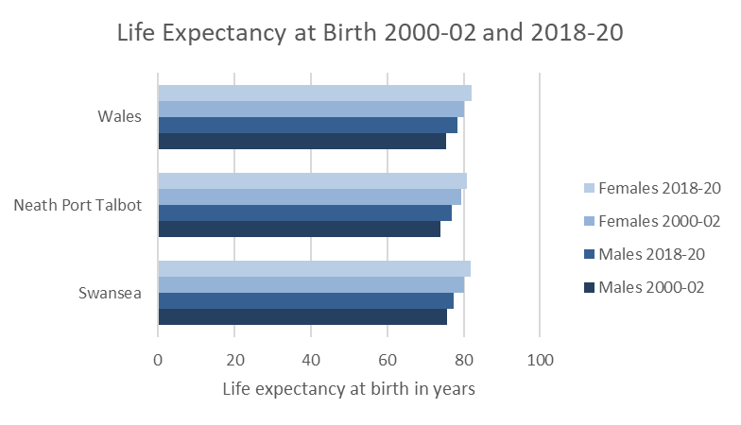
Source: Life expectancy estimates, all ages, UK - Office for National Statistics (ons.gov.uk)
Age Standardised Mortality Rates
The chart below shows the age standardised mortality rate for SBU areas for men and women.
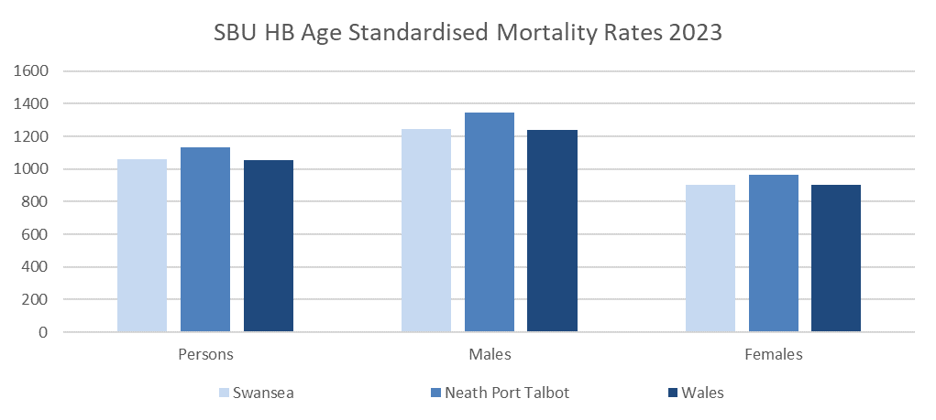
Age standardisation takes into account the different age structures of the Health Board’s population. The rates for the Neath Port Talbot and Swansea localities are slightly higher than the All-Wales rates. The rates are expressed per 100,000 population.
The above rate has now been calculated using the 2013 European Population Standard (ESP), replacing the 1976 ESP standards, which accounts for the significant change in the age standardised rates per 100,000 population when compared to previously reported figures.
Source: Deaths registered in England and Wales - Office for National Statistics (ons.gov.uk)
Deprivation
Deprivation is measured based on income, employment, health, education, geographical access to service, community safety, physical environment and housing. Wales has some of the highest levels of deprivation in the UK and SBU has more deprived communities than the average for Wales.
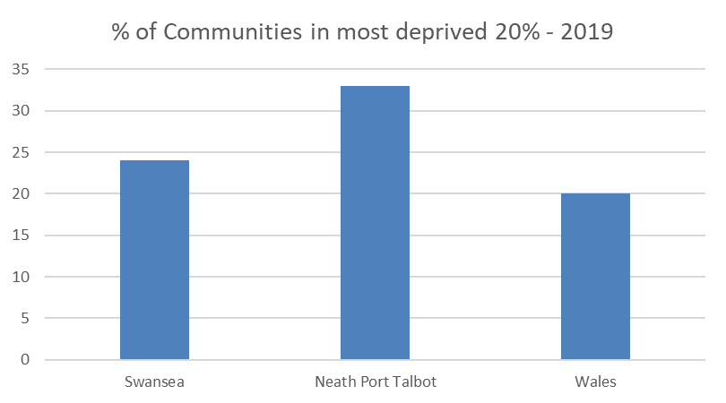
Deprivation is measured in 5 parts ranging from the least to the most deprived.
Source: Local Authority Analysis - Welsh Index of Multiple Deprivation - Stats Wales (statswales.gov.wales)
Perinatal Mortality
Swansea Bay’s perinatal mortality rate for 2023 (stillbirths and deaths within first 7 days of life as a rate per 1,000 live and stillbirths) is 9.3, the All-Wales average is 6.3.
Source: Deaths registered in England and Wales - Office for National Statistics (ons.gov.uk)
The Health Board reports all its perinatal mortality to both the MBRRACE-UK (Mothers and Babies: Reducing Risk through Audits and Confidential Enquiries across the UK) and the VON (Vermont Oxford Network) database and this helps the organisation to identify any outlier’s status. All the perinatal deaths are reviewed internally and validated externally using the PMRT (Perinatal Mortality Review Tool) to identify avoidable causes of death so learning could be imparted.

Excess Winter Deaths
In common with England and the rest of Wales, SBUHB has more deaths in the winter period.
For these purposes, winter is defined as the period between December and March and compares the number of deaths that occurred in this winter period with the number of deaths in the months prior and following the winter period.
Whilst some of the excess deaths during winter may be due to extreme weather conditions, often it is conditions known to be exacerbated by cold temperatures like stroke, heart attack, pneumonia and influenza. This is why it is important that we keep ourselves warm during the colder months and try to protect our most vulnerable citizens, ensuring they are vaccinated against infections such as influenza.
In the winter period of 2020/21, the number of excess winter deaths was higher than 2019/20. The average temperature for the period was lower than the previous 2 years.
Area Name | 2009-10 | 2010-11 | 2011-12 | 2012-13 | 2013-14 | 2014-15 | 2015-16 | 2016-17 | 2017-18 | 2018-19 | 2019-20 | 2020-21
Swansea | 21.9 | 14.6 | 12.5 | 15.1 | 13.4 | 28.2 | 19.2 | 21.2 | 25.8 | 11.3 | 12.5 | 28.2
Neath Port Talbot | 23.4 | 33.1 | 8.3 | 18.9 | 1.7 | 21.9 | 24.4 | 9.9 | 34.5 | 6.5 | 16.4 | 45.1
Wales | 17.5 | 20.4 | 12.8 | 18.1 | 10.3 | 25.1 | 17.4 | 17.7 | 32.3 | 13.3 | 10.0 | 30.9
Wales average winter temperature | 2.21 | 2.80 | 5.27 | 3.87 | 5.71 | 4.43 | 6.40 | 5.47 | 4.25 | 5.77 | 5.74 | 4.25

Source: Winter mortality in England and Wales - Office for National Statistics (ons.gov.uk)
Avoidable Mortality
Avoidable deaths are all those defined as
- Preventable:
All or most deaths from that cause could be avoided through public health intervention. E.g. Smoking related deaths.
- Amenable:
All or most deaths from that cause could be avoided through good quality healthcare. E.g. Asthma.
The table below shows the most recently data on avoidable deaths for Swansea Bay. Causes of death are considered avoidable for amenable and preventable causes according to European age-standardised rate (EASR) per 100,000 people for Swansea Bay UHB, 2014-2023.

 | Avoidable |  |  |  | Amenable |  |  |  | Preventable
 | Count | EASR (95% confidence Intervals) |  |  | Count | EASR (95% confidence Intervals) |  |  | Count | EASR (95% confidence Intervals)
2014 | 911 | 269 | (252-287) |  | 335 | 99 | (89-110) |  | 576 | 170 | (156-184)
2015 | 1,003 | 292 | (274-310) |  | 335 | 103 | (92-114) |  | 650 | 189 | (174-204)
2016 | 1,058 | 304 | (286-323) |  | 341 | 98 | (87-108) |  | 718 | 207 | (192-222)
2017 | 1,035 | 294 | (276-312) |  | 341 | 96 | (86-107) |  | 695 | 198 | (183-213)
2018 | 1,046 | 296 | (278-314) |  | 365 | 103 | (92-113) |  | 681 | 193 | (179-208)
2019 | 997 | 278 | (261-295) |  | 361 | 101 | (90-111) |  | 637 | 178 | (164-191)
2020 | 1198 | 335 | (316–354) |  | 405 | 113 | (102-124) |  | 794 | 222 | (207-238)
2021 | 1193 | 338 | (317-355) |  | 369 | 103 | (93-114) |  | 825 | 233 | (217-249)
2022 | 1075 | 306 | (288-325) |  | 369 | 105 | (94-116) |  | 706 | 201 | (187-216)
2023 | 1048 | 299 | (281-317) |  | 355 | 101 | (91-112) |  | 693 | 198 | (183-212)

This shows that the calculated rate of deaths that are considered as avoidable (which is shown as an age-standardised rate per 100,000 people). The All-Wales average in 2023 was 277.
It should be noted that the above is a statistical calculation based on analysis of the cause of death on the death certificate and is not based on specific in-depth reviews on individual deaths.
At SBUHB, all the secondary care deaths are scrutinised by Medical Examiner Service for Wales (MES) since February 2023, and this was extended to include primary care from September 2024. The Health Board has adopted the National Learning from Deaths Framework and created an efficient and effective system to ensure each of these referrals receives a proportionate investigation, and any themes collected, and learning shared across the health board and nationally.
Source: Avoidable mortality in England and Wales Statistical bulletins - Office for National Statistics (ons.gov.uk)
Deaths by Place of Occurrence
The below data demonstrates numbers of patients who die in a hospital rather than at home as the latter is considered better for patients who have a pre-confirmed cause of death. Percentage of deaths by place of occurrence 2023.
LHB Area | Home | Care Home |  | Hospices |  | Hospitals (acute or  community not  psychiatric) |  | Other  communal  establishments | Elsewhere
LHB Area | Home | Local  Authority | Non-Local  Authority | NHS | Non-NHS | NHS | Non-NHS
Betsi Cadwaladr | 26.50% | 1.20% | 16.20% | 0.00% | 3.60% | 49.60% | 0.00% | 0.10% | 2.70%
Powys Teaching | 25.60% | 3.10% | 16.20% | 0.00% | 2.50% | 49.10% | 0.00% | 0.00% | 3.40%
Hywel Dda | 32.00% | 2.40% | 16.30% | 0.00% | 0.70% | 45.80% | 0.00% | 0.10% | 2.60%
Aneurin Bevan | 30.20% | 0.80% | 12.10% | 0.00% | 2.40% | 51.50% | 0.00% | 0.20% | 2.80%
Cardiff & Vale | 29.60% | 0.36% | 15.30% | 0.00% | 4.90% | 46.80% | 0.00% | 0.20% | 2.90%
Cwm Taf Morgannwg | 29.30% | 1.00% | 10.10% | 0.20% | 0.10% | 56.10% | 0.00% | 0.50% | 2.80%
Swansea Bay | 32.30% | 0.60% | 15.40% | 0.00% | 0.00% | 47.20% (37.67%) | 0.00% | 0.50% | 4.00%
Wales | 29.40% | 1.20% | 14.40% | 0.00% | 2.10% | 49.70% | 0.00% | 0.20% | 2.90%
The above table shows that around 37.67% (1,680) of our population die in hospital compared to 49.7% (17,917) for Wales.
Source: Deaths registered in England and Wales - Office for National Statistics (ons.gov.uk)

In-Hospital Mortality
During the rolling 12-month period to July 2025 on average 161 people died in our hospitals per month. This is the lower than the previous period (163 for the previous period to April 2025).
Source: CHKS

Crude Mortality Rates
The crude rate for a site will be affected by not only the number of deaths but also by the number of admissions at a particular site. The rate shown is the actual number of deaths as a percentage of the total patients admitted. The Health Board rate is 1.24% (July 2025 – rolling 12 month).
We monitor the actual number of deaths at all our hospital sites on a monthly basis. This gives an early opportunity to investigate changes in the number of in-hospital deaths.
The crude mortality rates for the Health Board:
Monthly
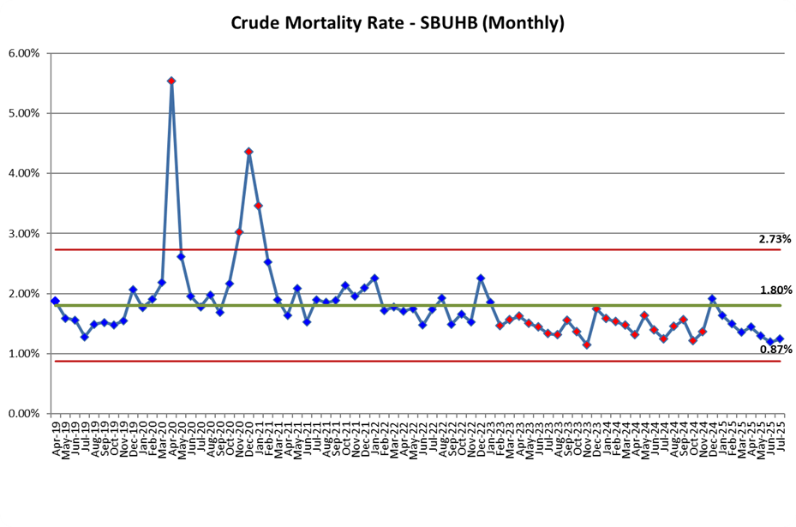

Rolling 12 Month
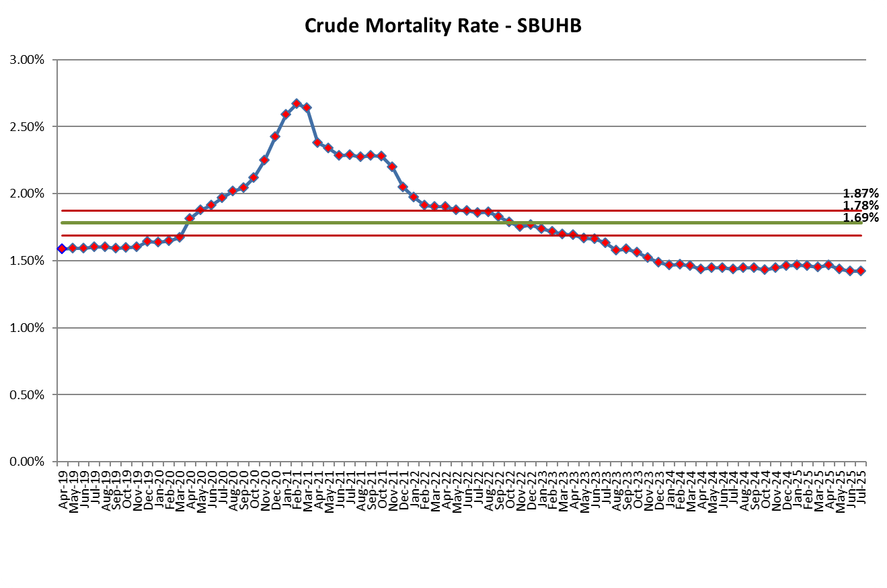
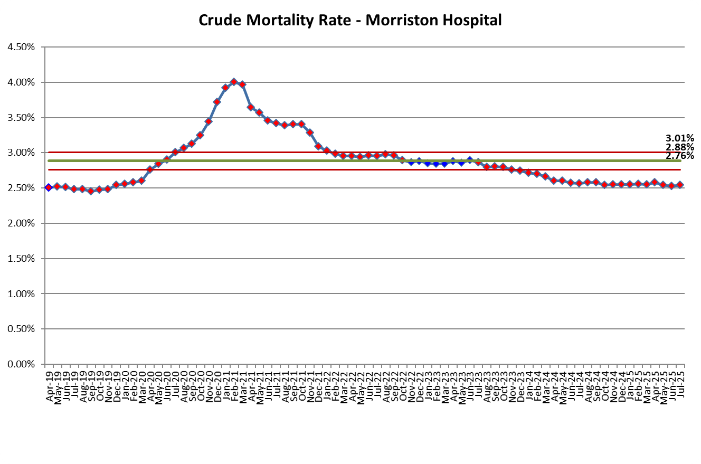
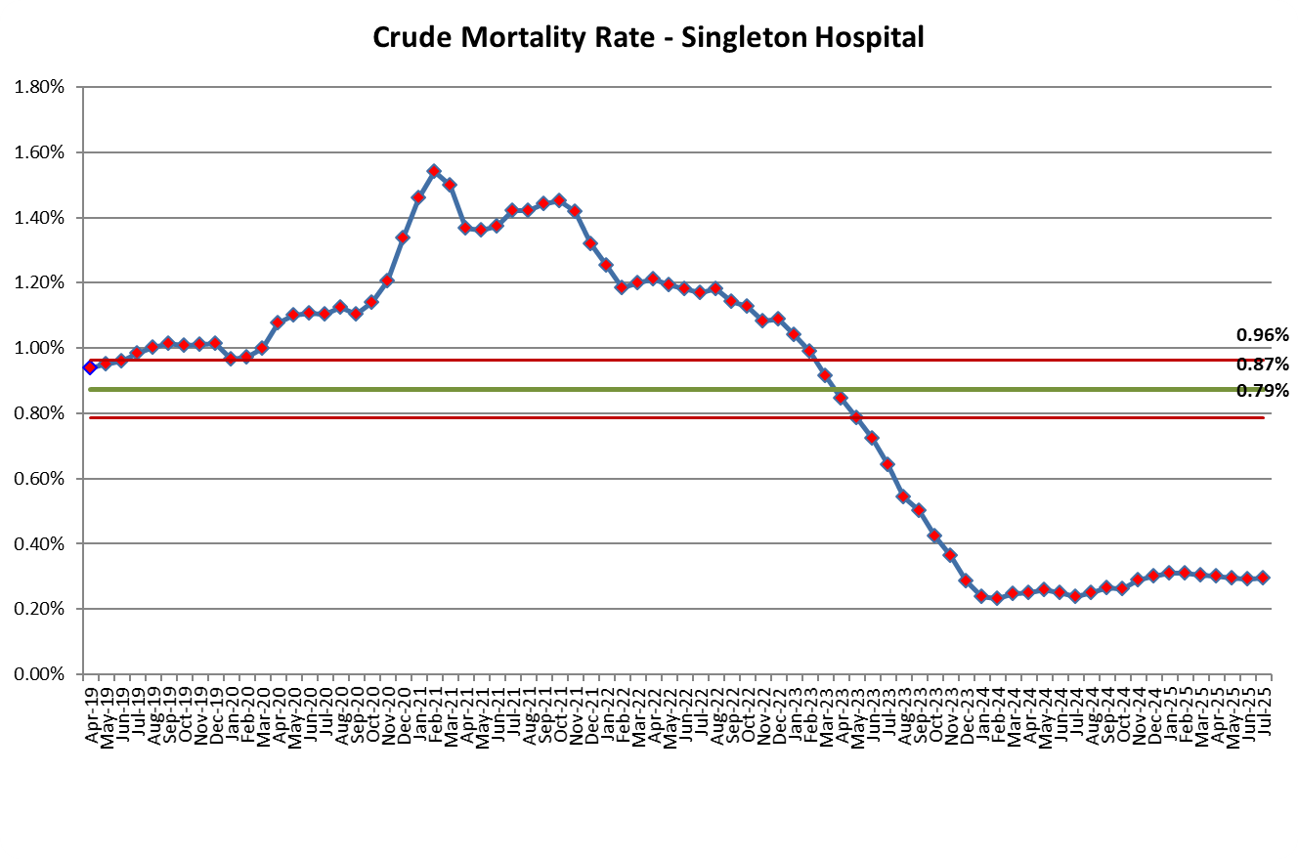
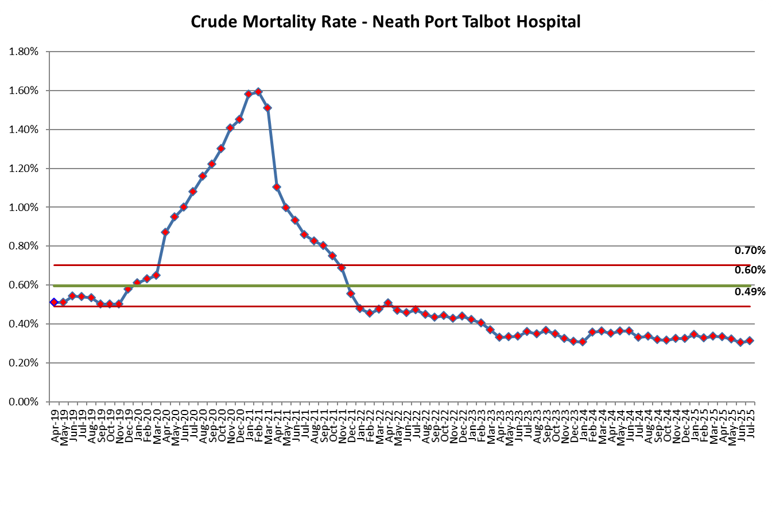
The above data show that more deaths occur at Morriston Hospital than other sites within the health board. This reflects the role of Morriston Hospital which is the single point of admission for acutely unwell patients. The Emergency department is located at Morriston which receives acutely unwell patients. The Intensive Care Unit is also located at Morriston it is the site where the most complex and high-risk surgery is performed. The reduction in mortality for Singleton Hospital reflects the changes made to acute medical admissions, which ceased being provided at Singleton from December 2022 onwards.
Condition-Specific Mortality
These measures focus on the deaths within 30 days of admission for three specific conditions with well-defined clinical pathways. The rate for each condition is affected by not only the number of deaths but also by the number of admissions for each condition, identifying admissions is achieved using clinically coded data. Coding targets are not currently being achieved, adversely affecting the number of admissions identified. For periods where coding completeness levels are low, the rate shown is likely to reduce as coding completeness improves.
Condition specific mortality helps to identify any variations in the care provided for the specific condition and is considered as a quality measure.
Hip Fracture
The Health Board rate of death in hospital within 30 days of admission with a hip fracture 5.70% for the rolling 12 months to March 2025, which is below the Welsh average (6.00%). The Health Board is exploring options to continue to make improvements to the broken hip (“Fracture Neck of Femur”) pathway and further reduce mortality figures by ensuring there is comprehensive geriatric cover for this elderly and frail patient population. In addition to this the service is exploring all options to address this while continuing to improve the "falls" pathway.
National Hip Fracture Database
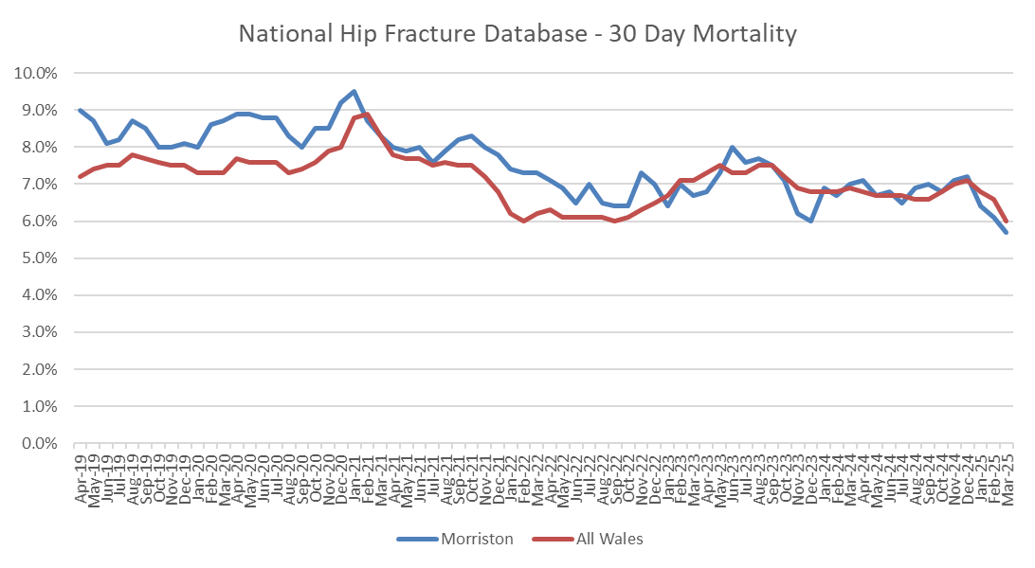
Source: Overall performance (nhfd.co.uk)

Stroke

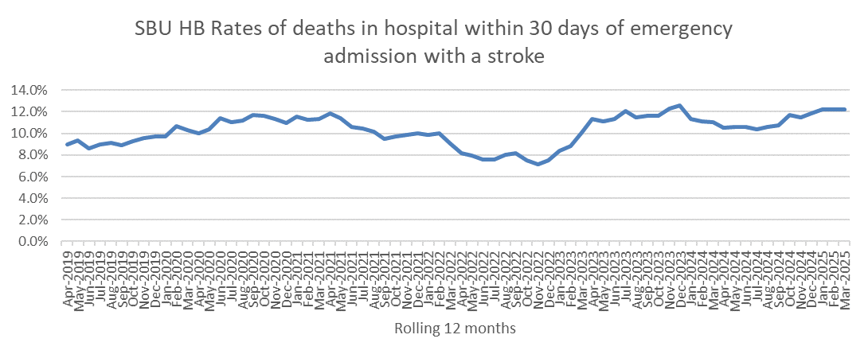
The Health Board rate of deaths in hospital within 30 days of emergency admission with a stroke is 12.2% for the rolling 12 months to March 2025, which is the same as the Welsh average.
A multi-disciplinary group of specialist stroke doctors, clinical nurse specialists, therapists and managers within the Health Board meets regularly with the aim of continually improving the delivery of stroke services so more patients regain good quality, independent lives following a stroke.
Heart Attack
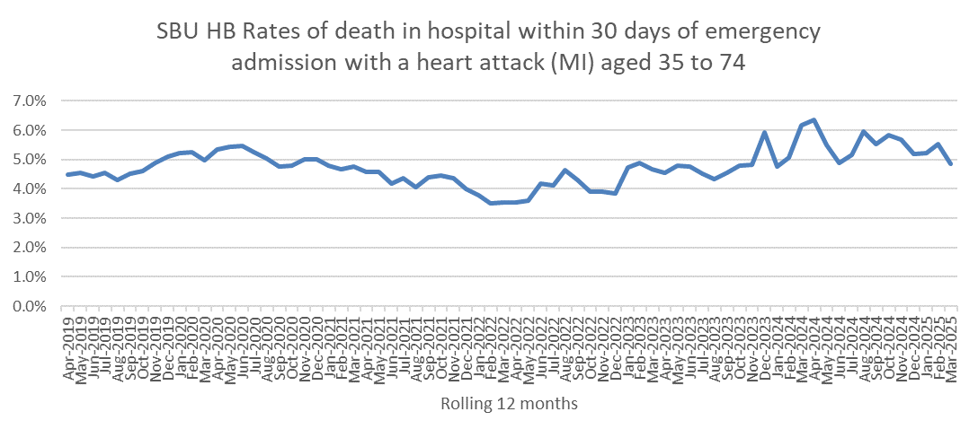
The Health Board rate of death in hospital within 30 days of emergency admission with a heart attack (MI) aged 35 to 74 is 4.9% for the rolling 12 months to March 2025, which is higher than the Welsh average of 3.7%.
In Wales, patients who are having heart attacks are transferred directly from the community to a ‘heart attack centre’ so that they can receive emergency treatment (called primary angioplasty) for a life-threatening condition. Multiple studies conducted in many countries have indicated that this results in the best overall outcome for patients.
Patients admitted to the University Hospital of Wales and to Morriston Hospital have the higher mortality rates overall because these two hospitals have the “heart attack centres” and receive and manage the sickest of these patients from the whole of South Wales. Those hospitals that no longer provide emergency treatment for heart attacks will be expected to have lower mortality rates since the remaining population will be less sick and therefore at much lower risk of dying.
All the deaths are reviewed regularly by the department to identify any amenable cause of death.
Rates of deaths within 30 days of surgery
These measures focus on the patients who died in hospital within 30 days of a surgical procedure.
Elective surgery is planned in advance and not time-sensitive, while emergency surgery is unplanned, often requiring immediate admission and treatment.
Elective Surgery
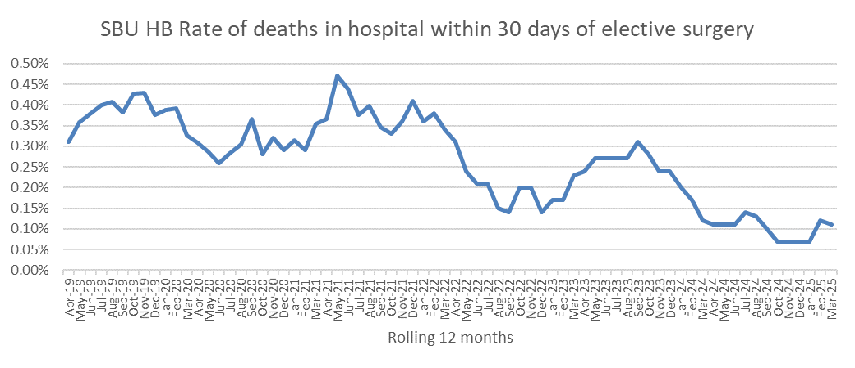
The rate of deaths within 30 days for elective surgery cases for SBU HB is 0.11%, higher than the All-Wales average is 0.07%.
Emergency Surgery
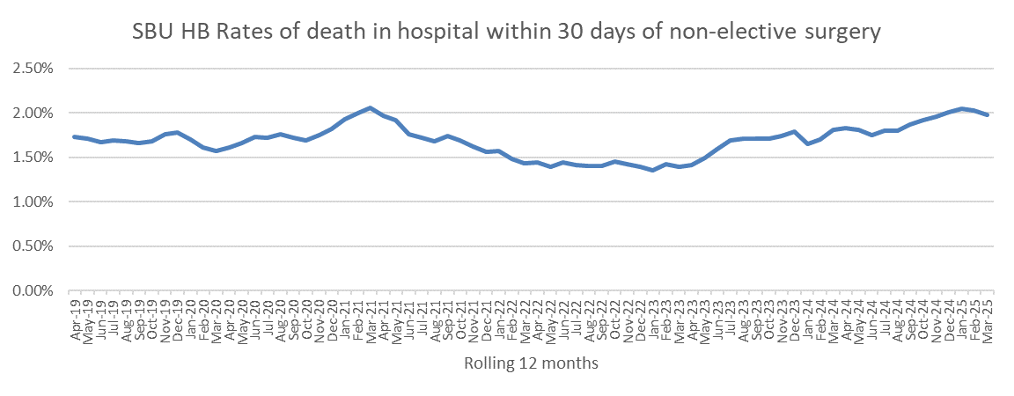
SBUHB has a higher rate of deaths for non-elective surgery to the Welsh average. The rate is currently 1.98%, the All Wales average is 1.71%

Accident & Emergency (Major Units) Crude Mortality Rates
The table below shows the rolling 12-month crude mortality rate for all Welsh Health Board sites with a major Emergency Department (ED) calculated as a rate per 10,000 attendances.
Rolling Annual Period | Wales | ABUHB Sites | Bronglais | Glangwili | Morriston | Prince Charles | Princess Of Wales | The Grange | Royal Glamorgan | UHW | Withybush | Wrexham Maelor | Ysbyty Glan Clwyd | Ysbyty Gwynedd
Apr-2019 | 18.1 | 16.9 | 7.5 | 16.5 | 24.1 | 16.1 | 15.8 |  | 13.5 | 13.8 | 24.1 | 22.8 | 28.9 | 18.7
May-2019 | 18.0 | 17.2 | 8.5 | 15.7 | 23.9 | 15.1 | 16.7 |  | 13.2 | 13.7 | 23.8 | 21.9 | 28.8 | 18.9
Jun-2019 | 18.2 | 17.9 | 8.2 | 15.5 | 23.9 | 15.5 | 17.2 |  | 13.2 | 14.0 | 23.7 | 21.3 | 28.7 | 19.6
Jul-2019 | 18.0 | 17.2 | 8.2 | 16.0 | 23.0 | 16.0 | 16.8 |  | 12.4 | 14.6 | 23.2 | 20.6 | 28.6 | 20.8
Aug-2019 | 18.2 | 17.3 | 8.8 | 15.8 | 22.8 | 17.2 | 16.0 |  | 12.9 | 14.5 | 22.8 | 21.3 | 29.1 | 20.6
Sep-2019 | 18.1 | 17.3 | 9.4 | 16.2 | 22.2 | 17.8 | 15.9 |  | 13.0 | 14.8 | 22.2 | 21.1 | 28.3 | 19.6
Oct-2019 | 18.0 | 17.4 | 8.5 | 16.2 | 22.6 | 18.0 | 16.7 |  | 12.7 | 14.9 | 22.4 | 19.9 | 27.1 | 19.5
Nov-2019 | 17.8 | 18.4 | 8.8 | 14.8 | 22.9 | 17.5 | 15.6 |  | 12.5 | 15.1 | 23.0 | 18.4 | 26.3 | 18.8
Dec-2019 | 18.1 | 18.2 | 9.4 | 16.1 | 23.6 | 17.5 | 15.5 |  | 13.0 | 14.9 | 24.6 | 18.3 | 26.4 | 19.5
Jan-2020 | 18.3 | 18.4 | 9.1 | 17.0 | 24.9 | 17.7 | 15.6 |  | 13.5 | 14.5 | 27.1 | 18.3 | 25.1 | 19.9
Feb-2020 | 18.0 | 18.1 | 9.1 | 16.8 | 25.1 | 16.2 | 14.9 |  | 12.0 | 14.7 | 26.6 | 17.7 | 26.0 | 19.1
Mar-2020 | 18.3 | 19.1 | 9.4 | 16.8 | 25.0 | 17.3 | 15.5 |  | 12.4 | 15.6 | 25.8 | 16.6 | 26.9 | 17.8
Apr-2020 | 18.7 | 19.4 | 10.6 | 17.6 | 25.8 | 17.8 | 15.8 |  | 13.2 | 15.7 | 26.1 | 16.1 | 27.4 | 17.7
May-2020 | 19.0 | 19.7 | 9.3 | 18.1 | 26.2 | 18.5 | 16.4 |  | 13.5 | 15.4 | 26.6 | 16.8 | 27.7 | 17.5
Jun-2020 | 18.9 | 19.5 | 9.2 | 19.8 | 26.1 | 18.5 | 16.8 |  | 13.1 | 15.2 | 25.9 | 16.2 | 27.9 | 17.0
Jul-2020 | 18.6 | 20.0 | 9.4 | 18.6 | 26.0 | 17.7 | 17.3 |  | 13.8 | 14.3 | 25.2 | 16.5 | 26.9 | 16.3
Aug-2020 | 18.2 | 18.7 | 8.4 | 18.4 | 25.6 | 17.0 | 17.5 |  | 13.0 | 14.7 | 25.9 | 16.4 | 25.8 | 16.0
Sep-2020 | 18.4 | 18.9 | 8.5 | 17.9 | 26.4 | 16.7 | 17.4 |  | 12.5 | 15.0 | 26.2 | 15.7 | 27.0 | 16.9
Oct-2020 | 18.8 | 19.4 | 9.6 | 17.7 | 26.0 | 18.3 | 17.6 |  | 13.4 | 15.2 | 26.7 | 15.4 | 27.8 | 16.4
Nov-2020 | 19.1 | 19.3 | 9.9 | 18.9 | 25.6 | 19.5 | 19.3 |  | 14.1 | 15.4 | 24.4 | 16.8 | 28.3 | 16.2
Dec-2020 | 19.9 | 20.9 | 12.1 | 18.7 | 26.7 | 20.2 | 21.2 |  | 14.8 | 15.9 | 23.8 | 17.8 | 27.3 | 15.9
Jan-2021 | 20.7 | 21.3 | 11.7 | 19.0 | 26.4 | 21.7 | 23.2 |  | 15.2 | 18.3 | 21.9 | 19.9 | 26.8 | 17.4
Feb-2021 | 21.3 | 22.3 | 12.2 | 20.6 | 26.4 | 22.4 | 23.2 |  | 16.5 | 19.2 | 22.7 | 18.7 | 27.4 | 18.4
Mar-2021 | 21.0 | 21.0 | 10.6 | 21.4 | 25.8 | 21.9 | 21.4 |  | 14.7 | 19.6 | 24.8 | 21.2 | 25.5 | 18.6
Apr-2021 | 20.3 | 19.9 | 10.0 | 20.0 | 24.5 | 20.5 | 21.0 |  | 14.0 | 19.3 | 23.7 | 22.3 | 24.6 | 18.4
May-2021 | 20.0 | 19.3 | 11.8 | 19.8 | 24.7 | 20.1 | 19.7 |  | 13.5 | 19.4 | 23.1 | 21.8 | 22.9 | 19.4
Jun-2021 | 19.9 | 17.9 | 11.7 | 18.3 | 25.6 | 20.0 | 18.1 |  | 13.7 | 19.5 | 25.1 | 23.1 | 23.0 | 20.0
Jul-2021 | 20.4 | 18.6 | 11.0 | 18.1 | 26.0 | 21.0 | 18.4 |  | 13.6 | 21.0 | 24.2 | 23.6 | 24.3 | 19.5
Aug-2021 | 20.9 | 20.1 | 11.7 | 18.7 | 26.8 | 20.6 | 18.6 |  | 13.9 | 20.8 | 23.6 | 24.2 | 24.5 | 20.2
Sep-2021 | 20.8 | 19.6 | 11.1 | 19.0 | 26.4 | 21.3 | 18.3 |  | 14.2 | 21.3 | 23.1 | 25.3 | 23.9 | 19.0
Oct-2021 | 21.1 | 20.6 | 11.6 | 19.4 | 26.5 | 21.0 | 16.6 |  | 14.4 | 21.5 | 24.7 | 26.4 | 23.6 | 19.1
Nov-2021 | 22.4 |  | 11.0 | 19.2 | 26.3 | 19.6 | 14.6 | 31.8 | 14.4 | 22.0 | 27.7 | 26.7 | 24.3 | 19.1
Dec-2021 | 22.4 |  | 8.9 | 18.6 | 27.1 | 20.7 | 13.2 | 30.0 | 13.4 | 23.1 | 26.8 | 27.7 | 24.4 | 19.9
Jan-2022 | 21.5 |  | 9.1 | 17.8 | 26.7 | 19.7 | 11.9 | 28.3 | 12.8 | 22.1 | 27.8 | 26.5 | 24.3 | 18.2
Feb-2022 | 21.4 |  | 10.3 | 17.0 | 26.5 | 19.8 | 12.3 | 27.9 | 13.4 | 21.5 | 27.7 | 26.7 | 25.3 | 17.2
Mar-2022 | 21.6 |  | 11.5 | 16.2 | 28.4 | 19.5 | 13.4 | 28.2 | 13.3 | 21.6 | 26.9 | 25.5 | 26.1 | 17.0
Apr-2022 | 22.2 |  | 12.1 | 17.0 | 29.0 | 20.9 | 13.6 | 29.0 | 14.0 | 22.1 | 27.9 | 24.9 | 27.6 | 16.6
May-2022 | 22.5 |  | 11.0 | 16.3 | 29.6 | 21.6 | 13.6 | 29.3 | 13.7 | 22.8 | 28.4 | 25.7 | 28.8 | 15.6
Jun-2022 | 23.0 |  | 11.8 | 16.4 | 29.0 | 23.2 | 13.8 | 30.5 | 14.1 | 23.6 | 27.3 | 26.0 | 29.9 | 16.1
Jul-2022 | 23.5 |  | 12.6 | 17.5 | 30.2 | 23.3 | 13.9 | 30.6 | 15.6 | 23.5 | 30.0 | 26.9 | 28.6 | 17.1
Aug-2022 | 24.0 |  | 12.9 | 19.7 | 30.9 | 23.7 | 14.7 | 29.5 | 15.7 | 24.9 | 29.6 | 26.9 | 30.2 | 16.9
Sep-2022 | 24.3 |  | 13.3 | 19.8 | 32.2 | 23.6 | 15.4 | 29.6 | 15.3 | 24.7 | 30.7 | 26.1 | 30.9 | 18.1
Oct-2022 | 24.4 |  | 12.2 | 19.0 | 32.8 | 24.5 | 16.1 | 28.5 | 14.2 | 25.1 | 30.5 | 27.6 | 32.6 | 17.5
Nov-2022 | 24.7 |  | 12.8 | 19.2 | 33.5 | 26.2 | 17.1 | 27.6 | 14.2 | 25.3 | 29.3 | 28.2 | 32.5 | 18.5
Dec-2022 | 25.7 |  | 14.8 | 19.0 | 36.1 | 25.9 | 19.4 | 29.2 | 14.6 | 25.4 | 32.4 | 27.2 | 34.1 | 19.6
Jan-2023 | 26.5 |  | 17.2 | 21.0 | 37.4 | 27.0 | 19.3 | 30.5 | 14.7 | 26.1 | 31.2 | 28.6 | 35.1 | 21.0
Feb-2023 | 26.4 |  | 16.8 | 19.9 | 38.0 | 27.3 | 18.9 | 29.8 | 14.4 | 26.7 | 31.6 | 29.8 | 33.0 | 20.8
Mar-2023 | 26.6 |  | 17.3 | 19.8 | 38.6 | 27.9 | 19.5 | 29.8 | 15.1 | 26.0 | 32.4 | 30.9 | 33.0 | 21.8
Apr-2023 | 26.6 |  | 17.2 | 20.5 | 40.1 | 27.4 | 20.5 | 29.1 | 14.7 | 26.1 | 31.4 | 31.1 | 32.6 | 22.9
May-2023 | 26.5 |  | 17.5 | 21.6 | 40.2 | 26.8 | 20.3 | 28.9 | 14.5 | 25.7 | 30.4 | 31.6 | 31.9 | 23.6
Jun-2023 | 26.2 |  | 16.4 | 21.8 | 41.0 | 26.4 | 20.8 | 28.5 | 14.7 | 24.5 | 30.5 | 31.4 | 32.6 | 22.8
Jul-2023 | 25.9 |  | 16.4 | 22.5 | 41.5 | 25.3 | 20.8 | 27.7 | 14.1 | 24.0 | 29.3 | 31.4 | 34.5 | 21.8
Aug-2023 | 25.6 |  | 16.7 | 20.3 | 42.6 | 26.0 | 19.8 | 28.0 | 14.5 | 22.6 | 32.0 | 30.7 | 32.5 | 21.9
Sep-2023 | 25.3 |  | 16.0 | 20.0 | 42.7 | 25.7 | 20.0 | 27.7 | 15.3 | 21.5 | 31.1 | 30.4 | 32.7 | 21.8
Oct-2023 | 24.4 |  | 15.9 | 20.8 | 42.0 | 23.7 | 19.3 | 26.5 | 14.8 | 20.1 | 30.5 | 28.9 | 30.6 | 23.9
Nov-2023 | 24.0 |  | 15.9 | 20.7 | 42.2 | 23.1 | 19.2 | 25.9 | 14.4 | 18.9 | 29.5 | 28.2 | 29.8 | 24.2
Dec-2023 | 22.6 |  | 15.2 | 20.8 | 38.7 | 22.3 | 16.5 | 24.6 | 14.1 | 16.9 | 26.9 | 28.9 | 28.8 | 23.4
Jan-2024 | 21.7 |  | 13.5 | 19.8 | 37.3 | 21.4 | 16.8 | 23.9 | 13.4 | 15.2 | 27.0 | 28.6 | 28.0 | 22.3
Feb-2024 | 21.9 |  | 13.7 | 20.3 | 37.7 | 20.6 | 18.2 | 24.8 | 13.0 | 14.3 | 25.8 | 27.8 | 29.1 | 22.1
Mar-2024 | 21.8 |  | 12.6 | 21.4 | 38.1 | 20.0 | 18.3 | 24.8 | 12.5 | 13.8 | 25.5 | 27.1 | 30.2 | 21.5
Apr-2024 | 22.1 |  | 12.6 | 21.7 | 38.8 | 20.1 | 16.8 | 25.7 | 13.0 | 13.2 | 25.7 | 28.3 | 29.7 | 22.5
May-2024 | 22.3 |  | 12.2 | 22.0 | 39.2 | 20.0 | 17.4 | 25.3 | 14.2 | 12.8 | 26.7 | 29.0 | 30.3 | 22.4
Jun-2024 | 22.7 |  | 13.2 | 23.4 | 39.9 | 19.8 | 17.7 | 25.6 | 14.3 | 13.1 | 27.9 | 28.7 | 29.0 | 22.9
Jul-2024 | 22.7 |  | 13.2 | 23.2 | 38.8 | 20.5 | 17.9 | 25.1 | 14.9 | 12.6 | 27.7 | 28.1 | 29.2 | 23.3
Aug-2024 | 22.9 |  | 12.2 | 24.1 | 38.7 | 20.1 | 17.8 | 25.0 | 14.7 | 12.5 | 26.2 | 28.9 | 30.1 | 24.8
Sep-2024 | 23.3 |  | 12.9 | 25.5 | 39.2 | 20.4 | 17.5 | 25.5 | 14.2 | 12.6 | 26.4 | 30.3 | 30.2 | 25.8
Oct-2024 | 23.6 |  | 13.2 | 25.8 | 39.8 | 20.1 | 17.7 | 25.6 | 14.9 | 13.5 | 25.4 | 29.4 | 31.1 | 25.3
Nov-2024 | 23.6 |  | 13.1 | 25.2 | 40.0 | 19.8 | 16.5 | 26.2 | 14.6 | 14.0 | 25.8 | 28.6 | 31.5 | 26.6
Dec-2024 | 23.9 |  | 12.1 | 24.8 | 41.5 | 18.7 | 17.1 | 25.4 | 14.8 | 14.9 | 27.8 | 27.8 | 32.1 | 26.7
Jan-2025 | 24.7 |  | 13.7 | 24.6 | 43.5 | 18.6 | 16.7 | 25.4 | 16.9 | 15.8 | 30.4 | 28.0 | 32.1 | 27.8
Feb-2025 | 24.7 |  | 13.7 | 23.9 | 44.8 | 19.0 | 16.1 | 23.6 | 18.9 | 15.8 | 29.5 | 27.9 | 32.1 | 29.5
Mar-2025 | 24.8 |  | 13.8 | 23.9 | 44.9 | 19.2 | 14.8 | 24.0 | 19.8 | 16.1 | 28.0 | 28.4 | 30.8 | 31.2
Apr-2025 | 24.4 |  | 13.4 | 22.9 | 44.1 | 19.3 | 14.5 | 23.9 | 19.1 | 15.4 | 28.5 | 28.1 | 31.2 | 31.0

Rolling Annual Period | Wales | ABUHB Sites | Bronglais | Glangwili | Morriston | Prince Charles | Princess Of Wales | The Grange | Royal Glamorgan | UHW | Withybush | Wrexham Maelor | Ysbyty Glan Clwyd | Ysbyty Gwynedd
May-2025 | 24.1 |  | 13.1 | 23.4 | 44.4 | 18.7 | 14.0 | 23.1 | 18.0 | 15.0 | 28.6 | 26.7 | 31.9 | 31.0
Jun-2025 | 23.8 |  | 12.4 | 22.1 | 42.3 | 17.8 | 14.1 | 23.2 | 17.6 | 15.1 | 26.4 | 27.2 | 32.6 | 32.0
Jul-2025 | 23.4 |  | 11.4 | 21.7 | 42.1 | 16.8 | 13.4 | 23.1 | 17.1 | 15.6 | 25.9 | 26.2 | 31.1 | 32.8

ABUHB Sites includes data for the Royal Gwent and Neville Hall up to mid-November when the Grange University Hospital was opened. Between November 2020 - October 2021 all 3 hospitals are included in the data, however as from November 2021 only the Grange University Hospital data is shown (to allow for 12 months rolling data), to align with the revised model of emergency care in the region.

The higher mortality observed at Morriston reflects a number of complex factors. As alluded earlier, unlike most other health boards, which have more than one hospital sites that receive acute admissions, Morriston Hospital is the only site in SBUHB that is the point of admission for all the acute patients. In addition, the mortality in ED reflects all patients seen and, other centres’ Emergency Departments see the most unwell patients (‘Majors’) and the least sick (‘Minors’), the majority of the least unwell patients in SBUHB are seen at the Neath Port Talbot Minor Injuries unit (NPTMIU). Approximately 50,000 people are seen each year in NPTMIU, but their outcome data are not reflected in the ED mortality figures. The crude ED mortality rate for SBUHB would be 25 (similar to other large units in Wales) if the NPTMIU data were to be included.

However, we also acknowledge that poor flow through inpatient beds also contributes to the number of deaths in ED and can mean that some patients who are not expected to survive their illness, may die in the emergency department rather than in an inpatient bed on a ward. We recognise that this is not the standard of end-of-life care that we would wish to provide and is integral to the continued work on improving the flow of patients into hospital and their discharge back to the community.

All deaths that occur in Morriston ED are reviewed by the department to identify areas for improvement or learning. The cases are also reviewed independently by the Medical Examiner Service for Wales (MES) who will inform the health board of any deaths that has raised a concern. Of the 332 ED deaths reviewed in 2024 by the MES, 82 were flagged for a further review. The reasons for review could be multitude, including communication issues, incomplete DNACPR to an avoidable cause of death. All the 82 cases were reviewed by the Health Board’s multi-disciplinary Learning from Death panel and one case was escalated for proportionate investigation. No amenable cause could be identified in any of the other deaths. The ED have been informed about the other cases to ensure learning is undertaken.

