
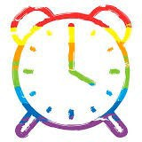
NHS Wales Virtual Pride Week
24-29th August 2020

Monday  24th | Tuesday  25th | Wednesday  26th | Thursday  27th | Friday  28th | Saturday  29th
NHS Wales LGBT+ Poetry Booklet & Winning Poem Reading | * | Gender Identity Panel Discussion  Book Here | LGBTea time Cuppa & Cake discussion session (10-11AM)  Join Microsoft  Teams Meeting | NHS Wales LGBT quiz night  Book Here | NHS Wales supports Pride Cymru
LGBT+ Film Festival, hosted by Iris Prize

Book Here


#NHSWALESPRIDE
#PRIDEGIGCYMRU

