Patient information — external disease and corneal services
Corneal transplantation: endothelial keratoplasty
(EK, also known as DSAEK or DMEK)

Why do you need a corneal transplant? The cornea is a window of transparent tissue at the front of the eyeball. It allows light to pass into the eye and provides focus so that images can be seen. Various diseases or injury can make the cornea either cloudy or out of shape. This prevents the normal passage of light and affects vision.
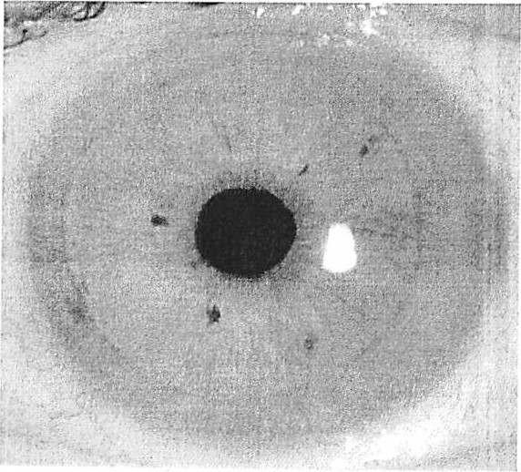
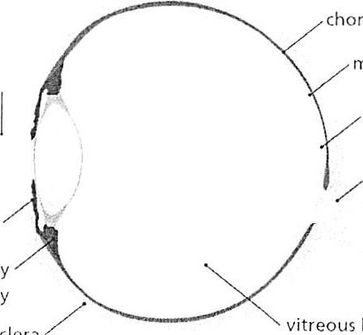
macula cornea retina optic nerve
choroid
body
iris
ciliary body
sclera
The cornea has three layers (thin outer and inner layers and a thick middle layer). In some diseases, only the inside layer (endothelium) is affected, causing corneal oedema (swelling) and clouding (see below).
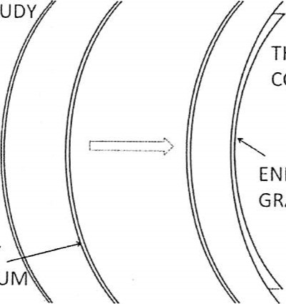
THICK, CLOUDY
CORNEA
THIN, CLEAR
CORNEA
ENDOTHELIAL GRAFT
UNHEALTHY
ENDOTHELIUM
BEFORE EK AFTER EK
Endothelial keratoplasty is a modern technique to replace the inside layer of your cornea with the inside layer from a donor cornea through a relatively small incision (opening).

Benefits of endothelial keratoplasty Improved vision
The majority of transplant recipients have sufficiently good vision to be able to drive legally although many need glasses. It can take up to six months until the full improvement is appreciated.
Comfort is improved in some cases.

Risks of endothelial keratoplasty Rare but serious complications
- Sight-threatening infection (1 in 1,000) Severe haemorrhage causing loss of vision
- Retinal detachment
- Severe inflammation or other rare causes of loss of vision

Corneal transplant rejection
A corneal transplant can be identified and attacked by your immune system. This happens in one in six patients in the first two years after transplantation and can cause graft failure. It can often be reversed if anti-rejection medication is started promptly. It remains a possibility for your lifetime.

Graft failure
When a graft fails, the cornea becomes cloudy again and vision becomes blurred.

Glaucoma
This can usually be controlled by eye drops, but occasionally requires surgery and can damage your sight.

Graft dislocation
About 10% of endothelial grafts dislocate and need to be repositioned in theatre.
Cataract
This can be removed surgically.

Possible advantages of EK over full thickness graft
- Faster recovery
- Fewer stitches, which means that the shape of the cornea is more "normal" and you are less dependent on glasses/ contact lens.
- Smaller wound so fewer wound complications such as leakage or wound rupture after accidental injury

About the operation

The operation is usually performed under local anaesthetic and takes about one hour. Through a small incision (opening), your endothelium is removed and an 8.5mm disc of donor endothelium is inserted and pressed in position against the back of your cornea by a bubble of air. You will need to lie flat for one hour after the operation. Usually, only two stitches are used to close the incision.

After the operation
You will usually be examined by the surgical team after your surgery and can generally go home the same day. You will be seen again the next day and within one week to make sure the graft stays in position. You will have about six visits to the outpatient clinic in the first year. We generally recommend that you take two weeks off work — discuss your individual circumstances with your doctor. You will need to use anti-rejection eye drops for at least six months and in some cases indefinitely. The stitches are usually removed at about three months.

What if my transplant fails?
A failed transplant can be replaced in a procedure known as a re-graft. However, the risk of subsequent rejection and failure increases each time for second and subsequent re-grafts.

Consenting for information sharing
We are required to share your information with the NHS Blood and Transplant Special Health Authority (NHSBT), who supply donor corneas, to comply with the law and to ensure high quality transplant material. However, to share this information, we require your consent to do so. If you do not give consent for your information to be
shared with or held by the NHSBT, this may affect availability of donor tissue for the transplant or create problems with contacting you should any problems be identified later on with the tissue you received. For more details please read the leaflet "NHS Blood and Transplant: Giving consent for use of your information" which can be found here: https://www.organdonation.nhs.uk/newsro om/publications/living donor consent.pdf

Corneal transplant rejection
Rejection needs urgent treatment as this can lead to failure of the transplant and loss of vision.

Symptoms of rejection are:
- Red eye
- Sensitivity to light
- Visual loss
- Pain
- IF YOU NEED ANY ADVICE OR FURTHER INFORMATION PLEASE CONTACT:
Rapid Access Eye clinic - 01792 205666 ext 5850
Or
Mr Saldanha’s secretary
Miss Helen Clarke, Medical Secretary to:
Mr. Mario Saldanha FRCS FRCOphth DO
Consultant Ophthalmologist,
Cornea, External Diseases and Refractive Surgery,
Singleton Hospital,ABMU Trust, Swansea
Honorary Senior Lecturer, Cardiff University

Tel: 01792 957627 Ext: 39627

