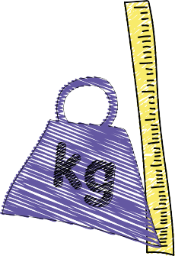
Information for parents about the .

Child Measurement Programme for Wales
We want to learn about how children in Wales are growing so that the NHS can better plan and deliver healthcare. We are working with School Nursing Teams across Wales to weigh and measure children in every reception class.

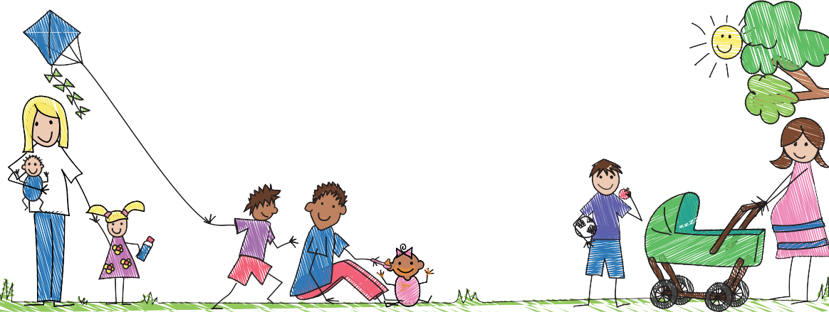What will happen?
- If you are happy for your child to be included in the
Child Measurement Programme, you don’t need to do anything. The School Nursing Team will measure your child’s class during the school year.
- To respect privacy, children will be measured in the quietest available area of the school.
- Your child will be asked to remove heavy clothes such as sweatshirts and shoes.
- Your child will stand on the scales to be weighed, and have their height measured.
May I see my child’s results? Yes, a letter from the school nurse will explain how.

Will everyone know my child’s height and weight?
No. Your child’s information is confidential and will be part of your child’s health record.
Does my child have to take part? No, but if you do not want your child to take part, you need to let your school nurse know as soon
as possible.
The more children that take part, the clearer picture we will have. More information and a video explaining the programme
can be found on our website: www.publichealthwales.org/ childmeasurement

Handy hints

for healthy families


up and about Bodies weren’t made to sit. Kids need
to walk, jump, run and move to be healthy.

5 a day
It’s important to eat at least 5 fruit and vegetables every day.

meal time
It’s important to have regular meals. make time for three regular meals: breakfast, lunch and dinner and eat together as often as you can.

snack check
It can be helpful to limit snacks to 2 a day. Try and
reduce unhealthy snacking –
foods containing a lot of sugar, salt or fat. Swap for healthier options.
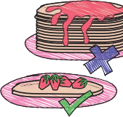
me-size meals Kids only need kid-sized meals. Too much food can be unhealthy.


sugar swap
Try swapping food and drink with added sugar for low sugar or
sugar-free options.

If you are interested in receiving more information on

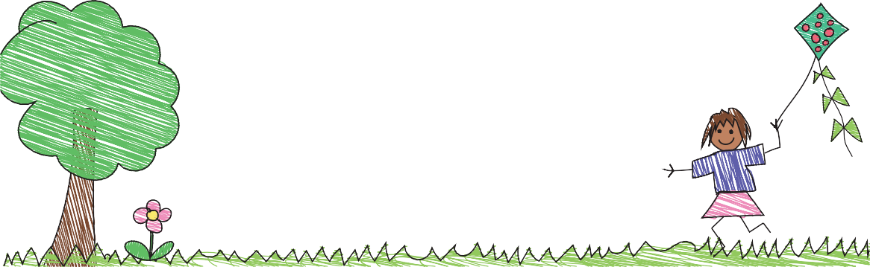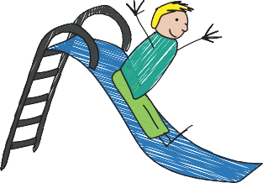
helping your children to stay fit and healthy please go to: www.everychildwales.co.uk

