Swansea Bay University Health Board

Vaccine Equity Strategic Plan

June 2024

Contents

1. Aim
1.1 Foreward
2. Background
3. What are the Immunisation Inequities?
4. The National Immunisation Framework for Wales 2022 (NIF 2022)
4.1 Provision for identifying groups with low vaccine uptake
4.2 Provision for determining barriers to immunisations
4.3 Partnership working and meaningful engagement with community champions, trusted voices and third sector organisations
4.4 Co-production of tailored interventions
4.5 Evaluation of actions and interventions
5. Formation of an Immunisation Service (driven by the NIF 2022)
6. Scope of Health Board approach to Vaccine Equity
6.1 Vaccine hesitancy
6.2 Utilising a theoretical model: COM-B
6.3 A framework for vaccine equity
7. Inequities in Swansea Bay UHB Vaccine Data
8. Swansea Bay’s priorities for Vaccine Equity Delivery during 2024/2025
9. Summary

Swansea Bay University Health Board
1. Aim
Vaccination equity is one of the core principles of the National Immunisation Framework for Wales (2022). All people across Swansea Bay UHB should have fair access and opportunities to discuss and receive all vaccinations. We want to work with our communities to offer additional tailored support to individuals, families and our communities. This will ensure they have they have the required information to make an informed choice, ensuring they are protected from vaccine preventable diseases through timely vaccination.

1.1Foreword
Vaccination is one of the most successful and cost-effective interventions which saves countless lives around the globe (SAGE, 2014). Since vaccines were introduced in the UK, diseases like smallpox and rubella that used to kill or disable millions of people – are either eradicated or seen very rarely.
Planning and the implementation of our COVID vaccination response meant we had to think differently to ensure protection of the population we serve across the Swansea Bay region. Collaborative working with multiple agencies allowed us to open Mass Vaccination Centres, Local Vaccination Centres in addition to various pop-up clinics across the region. We vaccinated in hospital wards, departments, GP practices, Community Pharmacies, Care Homes, Prisons and individuals’ homes. Collaborative and innovative working was paramount in our response which was evidenced by our partnership working with Neath and Port Talbot Council to develop our vision of a mobile vaccination unit, the Immbulance. We collaborated, planned and implemented specific arrangements for some marginalised groups, including those experiencing homelessness The Immbulance was also used to take the vaccine into communities, for example to refuge and faith centres.
Our first Swansea Bay UHB Vaccine Equity Strategic plan supports the strategic goals of the Population Health Strategy (2023) and our Quality Strategy (2023), and will build on the lessons learnt from our COVID vaccination response to ensure equitable access to all vaccines for our population, ensuring protection against vaccine preventable diseases.

2. Background
Vaccination equity is central to Swansea Bay UHB’s goal for delivering a patient centred, effective, efficient, equitable and safe vaccination service. Our response to the COVID vaccination programme, enabled us to respond differently to ensure the protection of our population, and in doing so, strengthened our links with community groups, and partner organisations. Our Equality Impact Assessment, highlighted gaps and barriers in our initial approach. We worked with, and listened to key individuals within our communities and changed our approach, to ensure no one was left behind to receive a timely offer of a COVID vaccine. Our learning from this will inform our plans to reduce immunisation inequities for all programmes.
Swansea Bay UHB provides services across urban, rural and industrial communities, including the City of Swansea, the towns of Neath, Pontardawe, the Swansea Valleys and the Port Talbot area. We have populations with diverse linguistic and cultural needs, including Chinese, Bangladeshi, Eastern European, Middle Eastern, African as well as and other Asian communities. Many international students attend Swansea University, with non-English speaking children being part of family groups within the University. Swansea was the first Welsh city to become a City of Sanctuary, a city that is committed to building a culture of welcome, especially for asylum seekers and refugees seeking sanctuary. The Welsh language is thriving within areas of Swansea Bay UHB and 19.65% of our population aged 3 and over can speak Welsh (WG, June 2022. However, we recognise that the importance of multi-lingual healthcare for all patients in Wales is fundamental and particularly important for people with mental health problems, people with learning disabilities as well as older and younger people.
Swansea Bay has relatively more deprived communities than average for Wales with over one in four of our communities falling into the most deprived category, particularly in urban parts of Swansea, Neath Port Talbot and the upper valley communities.
Figure 1. Swansea Bay IMD Map (2019)

3. What is equality, equity and inequality?
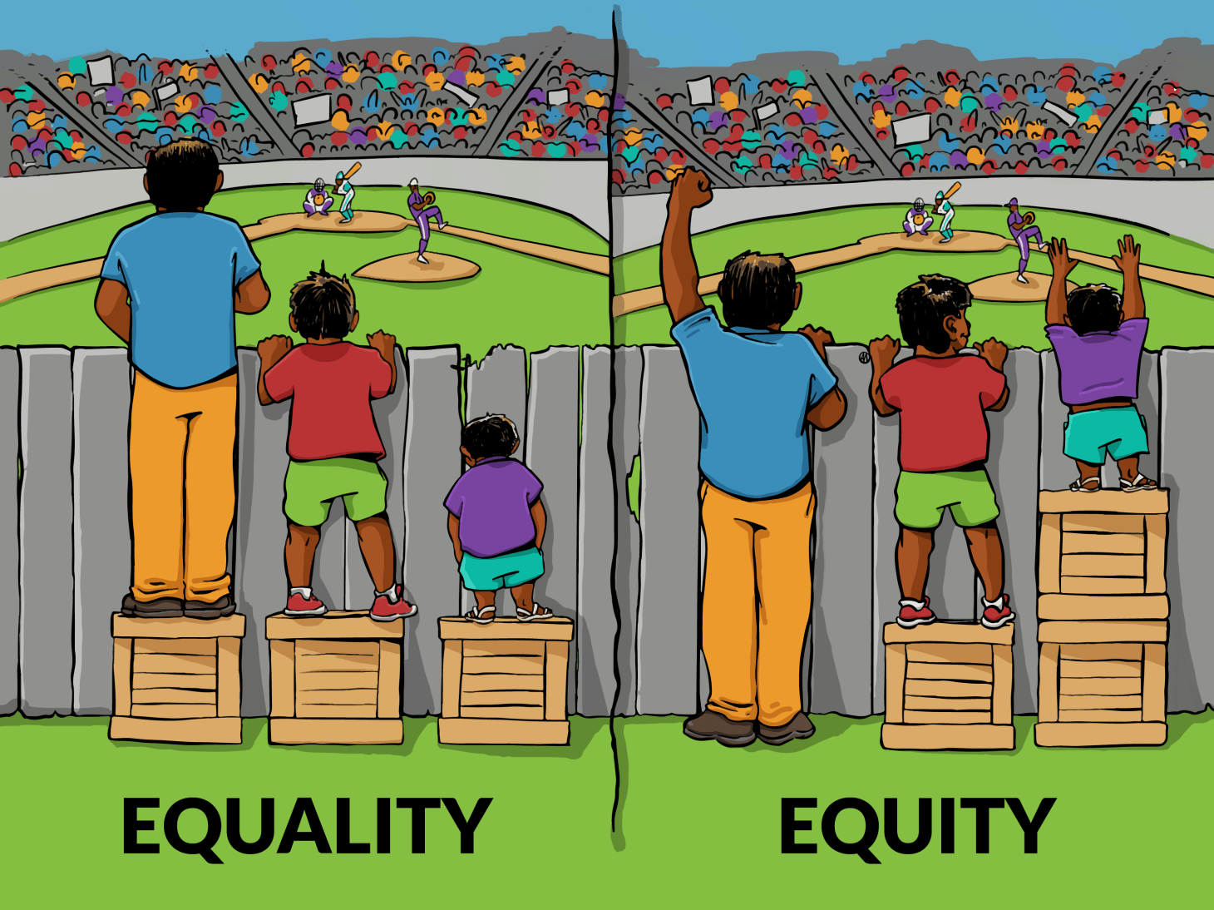

Image from: Interaction Institute for Social Change | Artist: Angus Maguire
The terms equality, equity and inequality are used to describe the way in which people are treated by society. Although they are often used interchangeably, each of them has a slightly different meaning and are important concepts that have to do with fairness and justice.
3.1. Equality
In its simplest terms means each individual or group of people are given the same resources, time, money, opportunities etc and hence are treated in the same way. Equality is about making sure people are treated fairly. Our age, disability, faith or belief, gender, race, sexual orientation, being married or in a civil partnership, being transgender or being pregnant should not disadvantage us. These different characteristics are protected under the Equality Act 2010. We recognise whilst our standard Primary Care accessibility may be suitable for the majority of people, the approach won’t be suited to all for a multitude of reasons. Therefore, to be equitable in vaccinations tailored approaches will be considered to meet the suitability of the whole population.
- 3.2. Equity
- Vaccination equity implies that each individual has the same chance of being fully vaccinated, and that unfair disparities in vaccination uptake are eliminated. Immunisation equity recognises that people have different needs and assets and hence that people therefore need different opportunities, access, resources and support. Every person in Wales should have fair access to vaccination with a fair opportunity to receive their vaccination if they so choose. That is why additional and tailored support will be put in place for harder to reach and under-served groups, who may otherwise be left behind, worsening existing health inequalities. Addressing immunisation inequities helps improve uptake and is required to prevent, control, eliminate and eradicate vaccine-preventable diseases.

3.3. Inequality
Is the opposite of equality and in simple terms means someone has less than an equal share of something, they are in essence being treated differently. Inequity can be measured, for example by looking at the distribution of health, wealth, educational achievement or a number of other measures, in a population. Immunisation inequities are the avoidable differences in accessing immunisation programmes which lead to groups within the population, or individuals who share common characteristics, being left behind in immunisation.
We are committed to demonstrating our core organisational values (Caring for Each Other, Working Together and Always Improving). To ensure that we “live” our values and that we make the best decisions, which are fair for all our communities, we need to go beyond the requirements of the Equality Act 2010. To achieve this, we place importance on putting human rights at the heart of the way in which our services are designed and delivered. For example, we understand that many people have caring responsibilities which can affect the way they access services and/or employment. We believe that socio-economic status is a key factor affecting healthy outcomes and we take steps to consider these areas as part of our decision-making processes.

4.The National Immunisation Framework for Wales (NIF 2022)
Following on from the Pandemic response, WG published the first National Immunisation Framework (NIF) in October 2022.
The NIF outlines six priority areas of focus which are:
Vaccination Equity
Eligibility
Digitally enabled vaccination

Governance
Deployment
Public vaccination Literacy

In order for us to achieve the ambition set by WG, it is important to acknowledge how each of the remaining 5 priority areas are interlinked and can support vaccination equity across the Health Board. We will be guided by the development of new digital systems to focus our strategies in areas where uptake rates are lower, and based on our community links will be able to develop a deployment model suited to meet the needs of each community.

The National Immunisation Framework for Wales has guided Health Boards with five core principles that should be contained within our vaccine equity strategy, which are as follows:

Provision for identifying groups with low vaccine uptake
In order for us to improve our current performance, having confidence in our data sets is of pivotal importance. The development of local and National dashboards supports the identification of groups with lower vaccine uptake, however not all dashboards are ‘live’, such as COVER data. Having timely information is vital in order to achieve the ambitions set by Welsh Government. In light of this, we have begun the process of producing ‘live’ local dashboard in relation to MMR uptake, building on the success of our internal staff flu dashboard. We will continue to progress with our ambition locally held and timely data sets, with a view this will improve performance and reduce the inequality gap.
Recent work has highlighted incomplete vaccine records, and non-alignment of data between GP held records and CYPrIS. Significant work will continue to align this data, in the absence of a national data solution.
Some underserved groups may not necessarily be captured in current data sets (such as those not registered with health care) however given our established partnership working with key stakeholder together with our plans to strengthen relationships with our communities, this will provide us with the key information of the unvaccinated needed to inform our approach.

Provision for determining barriers to immunisations
The Health Board’s Immunisation Team, with the support of the Patient Experience Team, will work with our communities and partner organisations, to gather qualitative information regarding accessibility of vaccine, any misinformation about vaccines, negative experiences of vaccination journeys, and the influence of social media and family members on uptake of specific vaccines.
We will also work with key professionals who advise and administer vaccines for their knowledge on potential barriers to immunisation (flexibility of appointments for example and the need to offer a domiciliary immunisation approach) and provision for individuals moving in from abroad who need a review of their previous vaccination history. The immunisation service will look to support professionals with issues they feel are barriers to immunisation.
This engagement will inform our response to tackle barriers to vaccination leading to further partnership working with community champions, trusted voices and third sector organisations.
  - Partnership working and meaningful engagement with community champions, trusted voices and third sector organisations
We will continue to build on our engagement with our communities, and have already progressed to ensure discussions are now regarding all vaccinations rather than to that of COVID alone. We will continue to visit groups such as ‘Chai and chat’ and ‘BAME Mother and Toddler groups’, in addition to other nursery group projects. In collaboration with local authority partners, we worked during the summer months of 2023 to pilot a care home information session on COVID and influenza vaccines, to gain further insight as to why uptake in staff is low. Mis-information and accessibility were two main areas seen as barriers to uptake of both vaccines.
Moving forward we will look to work alongside further engagement groups, as well as approaching local specialist food markets to display flyers aimed at particular cohorts in the community such as Eastern European, Arabic, and Asian. We will use QR codes to allow information to be shared in multiple languages wherever possible.

Co-production of tailored interventions
We will engage with key individuals to understand what messages and resources would enhance the understanding of the importance of immunisations. For example, we are keen to work with school-aged children in the first instance, to gain further insight into what information and interventions would positively support immunisations across Swansea Bay.
In addition to this, we will work with Health Board colleagues, local authorities and National Teams to produce easily accessible information on our web pages, which will be translated in a number of languages and formats following our discussions with trusted voices.
We will work with key stakeholders to support a pilot to administer Fluenz in nursery settings from 2024/25 to ensure improved accessibility to the vaccine.

Evaluation of actions and interventions
Each targeted intervention will be evaluated to establish if the approach taken is effective and sustainable. If the tailored approach is effective, then it shall form part of future engagement plans with the communities. The evaluations will be managed through the Immunisation Governance Structure.

Formation of an Immunisation Service
The National Immunisation Framework stipulates Health Boards should form an Immunisation Team in order to support implementation of the NIF. Recognising the importance of vaccine equity, we have ensured expertise provided by a Senior Principal Public Health Practitioner is available within the team.

Functions of the Immunisation Service

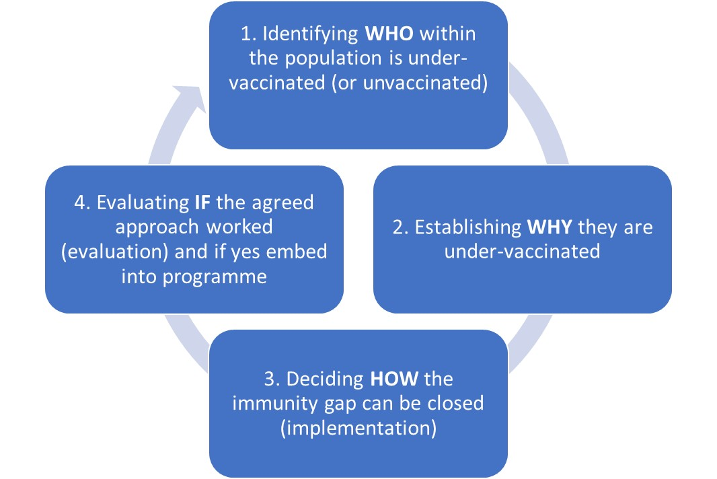

The Swansea Bay UHB Immunisation Team will work with existing services to:
- improve access to immunisation service providers;
- provide expert immunisation advice to service users who may be hesitant and
- work with service users to produce immunisation literature in a way which will support improved engagement with the immunisation service. In doing so, we will seek to improve immunisation uptake rates and reduce the inequality gap between the most deprived and least deprived areas across the region. We will do this by providing in-reach, outreach, tailored interventions, outbreak management and expert advice and support.
We will continue to work with trusted voices within our communities to ensure our immunisation service is patient centred, effective and efficient. Our social media platforms will reflect what service user want to see. All eligible individuals will know what vaccines they are due, and how to access these in a format they will understand.

A Quality Immunisation Service

Our Purpose
To protect the communities, we serve against vaccine preventable diseases.

Our Goal
Our local communities will be protected as we maximise vaccine uptake, reducing differences in uptake across the region by engaging with, listening to, and working with our local communities, tailoring our immunisation service to meet their needs.

In line with the Swansea Bay UHB Quality Strategy (2023) our Immunisation Service will be:

Safe – clinically led delivery of immunisations with public safety at the heart of all we do. We will provide a blended model of training to all who advise or administer vaccines, in line with the National Minimum Standards for Training.
Effective – Initiate incremental improvements in uptake rates of all vaccines and in due course, Welsh Government ambitions will be achieved and maintained.
Efficient – Engage with key stakeholders to provide an efficient service by Primary care and key stakeholders to ensure our immunisation clinics do not have waiting lists and will act on appointments where individuals do not attend (DNA). We will move across to a digitally enabled vaccination service, reducing the labour-intensive role of working with paper consent forms for example. This will mean our immunisation records system will be updated at point of contact.
Equitable – Working in collaboration with community groups and health care professionals who will inform us of local concerns regarding vaccine information and accessibility to services. We will work with key stakeholders to support improved uptake of vaccine via different delivery models when needed, such as deploying teams into a nursery setting or administering vaccines, such as shingles in citizens homes for example.
Timely – all eligible individuals will receive their vaccines when they are due to be administered. We will increase our support to primary care to ensure individuals who move into the UK receive a timely review of their previous vaccination history and are offered any outstanding appointments to bring them in line with the UK routine immunisation schedule.
Patient Centred – we want to ensure a positive patient experience for all who are due immunisations. We will engage with, and listen to individuals to ensure the service provided to them will result in a positive experience for them. Understanding the perspective of citizen and staff working within the service will help us guide our immunisations services and strategies tailored to their perspectives and needs.

Scope of Health Board approach to Vaccine Equity
Targeted interventions for the groups below can be considered across three interlinked dimensions
Protected characteristics:
Age; disability; gender reassignment; pregnancy and maternity; race; religion or belief; sex; sexual orientation

Socio-economic disadvantage:
People living in poverty; people who are socially excluded, or subject to discrimination
Inclusion health & under-served groups:
Sanctuary seekers; people experiencing homelessness; travellers; people involved in justice system; mental health clients

Vaccine Equity

- people with protected characteristics under the Equality Act 2010, including people from ethnic minority backgrounds and disabled people;
- those at socio-economic disadvantage living in communities with high deprivation or social exclusion;
- those within marginalised or under-served groups such as asylum or sanctuary seekers, people experiencing homelessness, people involved in the justice system, people affected by mental health issues and people from traveller communities who do not regularly access traditional healthcare services.

Our approach will also look wider, beyond traditionally marginalised groups, reflecting on the experiences of groups and communities during the pandemic to ensure a genuine ‘no one left behind’ approach. The routine, targeted and selective immunisation programmes occur across our lifespan. Whilst the programme is largely pro-active in the prevention of diseases, there will be the need to be re-active to the emerging threats of diseases, such as measles.

An evidence-based approach to Vaccine Equity – the use of models and frameworks

Vaccine hesitancy
Vaccine hesitancy refers to the delay in acceptance or refusal of vaccines despite availability of vaccination services which can lead to inequity. This term is used to cover the refusal, delaying acceptance of vaccines or using certain vaccines, but not others. Vaccine hesitancy is complex and context specific varying across time, place and vaccines. It includes factors such as complacency, convenience and confidence (WHO, 2014). However, it should never be assumed that vaccine hesitancy is the root cause of an immunisation inequity.

Utilising a theoretical model: COM-B

The WHO Tailoring Immunisation Programmes (TIP) is underpinned by evidence from behavioural science, which aims to define and understand which factors are necessary for behaviours to take place, and which factors increase the probability that a behaviour will occur (drivers) or decrease the probability (barriers). The theoretical model utilised in the TIP approach is the COM-B model, which we will utilise in our approach given its broad and flexible use for all individuals such as health care staff.
As illustrated below there are 3 overall factors that need to be in place in order for any health behaviour to occur. These are:
- Capability
- Opportunity and
- Motivation
The factors interact: capability and opportunity both influence motivation, whilst all three factors can influence behaviour. On the contrary, behaviour influences all three factors.
The COM-B model in relation to vaccination is as follows (taken from TIP)

A framework for vaccine equity

The All-Wales vaccine equity framework provides clear steer which will inform our priorities going forward both from a Governance perspective and a behaviour change perspective.
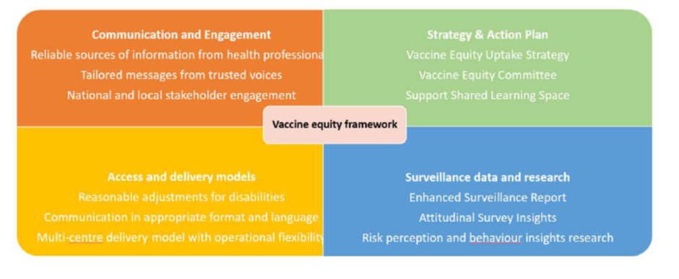

Inequalities in Swansea Bay UHB Vaccine Data

7.1 National Data
In relation to the uptake of the COVID-19 vaccine we can see:
- Black African and Asian population groups were less likely to receive the vaccine compared to white groups
- For this follows the national trend which indicates that post 2013 vaccines have a smaller uptake in the Black African and Black Caribbean groups than other ethnic groups
Homeless, Gypsy and BAME communities, people who experience homelessness and asylum seekers, often find it difficult to receive any vaccinations, which leads to then need of them finding additional avenues or not receiving any. When they are in a lot of cases the most vulnerable, and susceptible to illness.

7.2. Local Data
During the COVID campaign we noticed a sizeable gab between those residing in the least deprived areas compared with those in the most deprived. The uptake was significantly worse in these areas. This difference was evident in all of the vaccine eligible cohorts within the 2023 Autumn Campaign. The largest gap within all of the eligible cohorts is between 12-64 years who are household contacts of immunosuppressed citizens. Overall, the gap in uptake in eligibility groups was 22.8% between the least deprived (62.7%) and most deprived (39.9%).
Uptake was higher in rural compared to urban areas (54.0% vs. 50.5%). In most groups except contacts of people with immunosuppression, there was very little difference comparing urban to rural coverage. Ethnicity Coverage was higher in the Combined White ethnic groups compared to the combined Black, Asian, Mixed and Other (BAMO) ethnic groups. This was the case in all of the Autumn eligibility groups with the exception of Care home staff. The overall gap in all eligible was 21 percentage points between White (51%) and BAMO (30%).
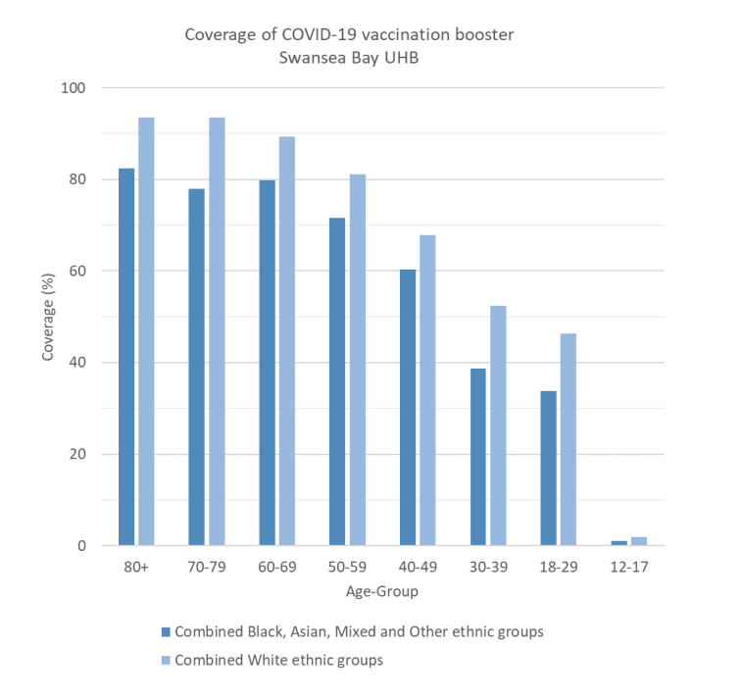
Figure 2: Coverage of Covid-19 Booster by age and ethnic groups, Swansea Bay UHB 10/03/22

Figure 3: Coverage of Covid-19 Booster by specific ethnic groups, Swansea Bay UHB 10/03/22
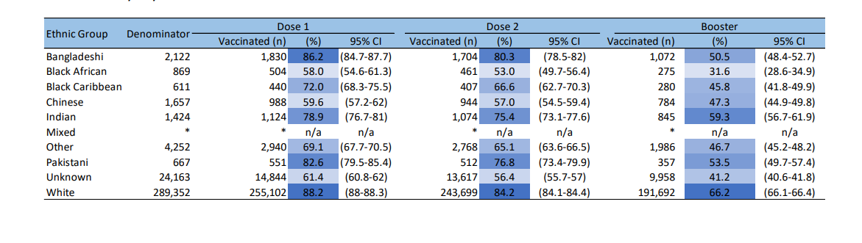
Figure 4: Uptake in 4 years old for all up to date immunisations 22/23
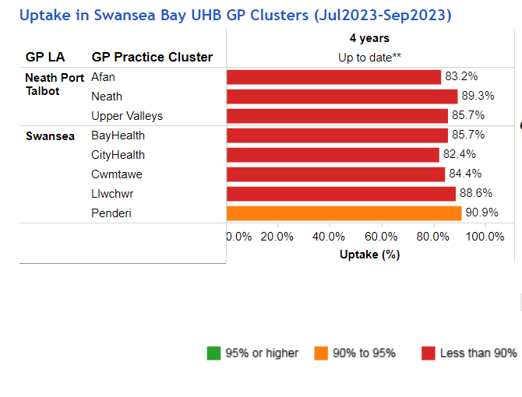

Figure 5: The proportion (%) of children up to date with routine immunisations by 1 years of age in Swansea Bay UHB 22/23
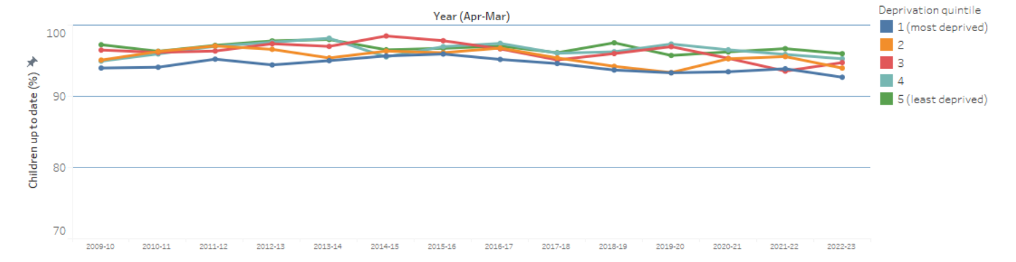

Figure 6: The proportion (%) of children up to date with routine immunisations by 2 years of age in Swansea Bay UHB 22/23
As we can see below (figure 6) the gap between the most deprived and least deprived quintiles has slightly increased, with uptake below 90% in the most deprived areas.

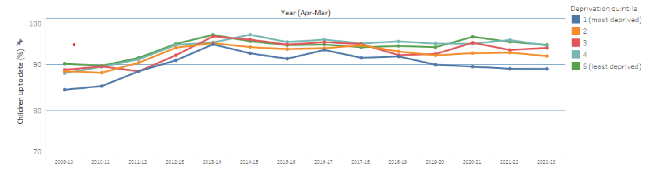

The following figures show overall uptake rates have reduced, with the least deprived areas now only achieving an uptake of 90%. However, the gap between the least and most deprived has further increased in this age group, with the most deprived quintile now around 80% uptake.

Figure 7: The proportion (%) of children up to date with routine immunisations by 4 years of age in Swansea Bay UHB 22/23
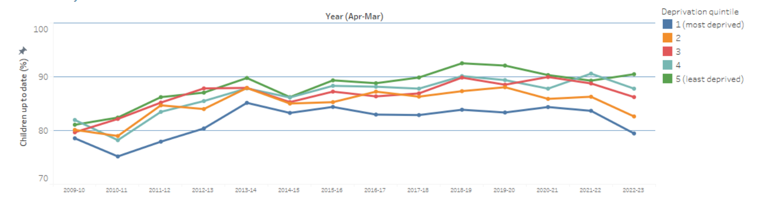
Whilst overall uptake rates remain lower than 95%, we can see below how the gap between most the deprived and least deprived quintiles has decreased, potentially due to school based catch up sessions.

Figure 8: The proportion (%) of children up to date with routine immunisations by 15 years of age in Swansea Bay UHB 22/23
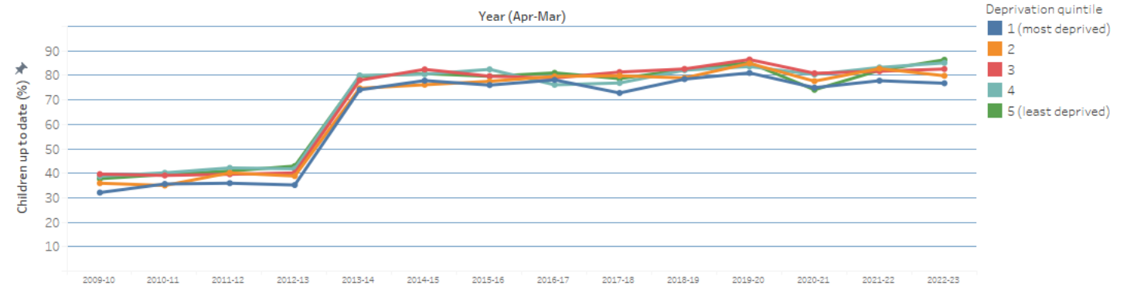
Figure 9: Swansea Bay UHB Cluster Summary Flu Immunisation uptake in patients 65 years and older 16/1/24
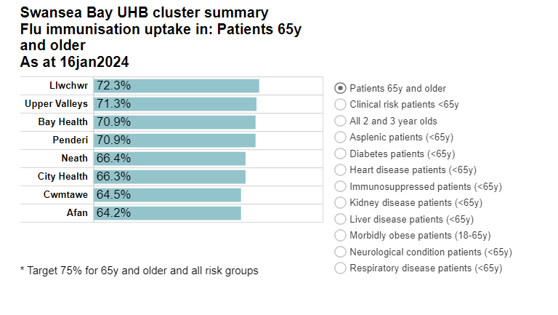

Looking at our information for MMR, we can see that the more deprived areas of Swansea, located within the City and Bay clusters are the lowest performing, we know these are the areas where our largest number of ethnic minority families reside.
Figure 10: – Uptake of MMR (1 dose) in children turning 2 years of age July 2022 – June 2023 by MSOA of residence Swansea Bay
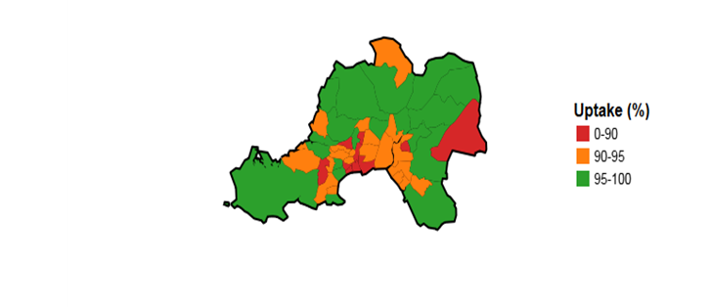

Figure 11: – Uptake of MMR (2 doses) in children turning 4 years of age July 2022 – June 2023 by MSOA of residence Swansea Bay
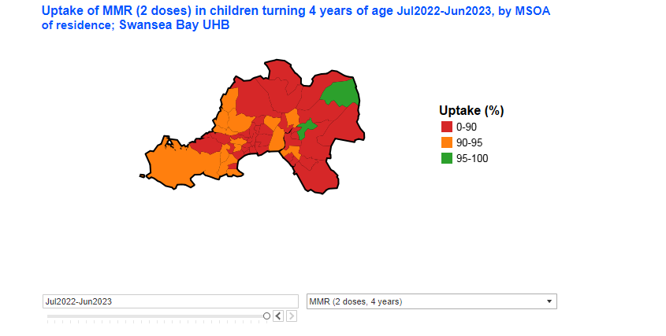

8. Swansea Bay’s priorities for Vaccine Equity delivery during 2024/25
Our priorities during 2024/25 will be as outlined below:

Data and Intelligence | Improving accessibility
Monthly data cleansing to ensure alignment of GP immunisation records and CYPRiS to ensure confidence in data, until a national solution is sought.  Produce practice level reports with details of uptake rates for all immunisation programmes. This will inform targeted work to understand why uptake rates of some vaccines is better than others in some areas.  Quarterly audit of immunisation information received into child health to ensure information received is complete and accurate. This will include immunisation histories of individuals who have moved into area, to ensure records for these individuals are accurate and an immunisation plan is in place.  COVER and IVOR data will be used to inform mobilisation of immunisation team to areas of lower uptake rates to offer targeted and/or tailored interventions. This will include school’s immunisation dashboards. We will continue to progress with a local dashboard which will provide timely information  Electronic consent for schools-based immunisation programmes will drive efficiencies, enabling earlier identification of families who have not returned consent or have declined. Two dashboards will be available – uptake of vaccine and non-return of consent  Database of children who are home educated to ensure awareness of which immunisation are due and when.  Live antenatal Hepatitis B database maintained for those on the selective immunisation programme  Local Child Health dashboard to show a live snap shot of uptake Childhood Immunisations at any time, identifying areas of lower uptake which will shape plans for targeted interventions  Home Educated data validation with Local Authority | Expansion of the domiciliary approach for individuals who cannot or who are unable to attend GP surgery for all immunisations. This will include vaccination in care homes for vaccines such as shingles for example.  Utilise additional pop-up venues for delivery of all vaccinations in Community settings. This will be achieved through collaboration with trusted voices and partnership with other key stakeholders.  Work with GP practices to offer flexible/ opportunistic vaccine appointments for those who cannot attend routine immunisation clinics  Expansion of Booking Team functionalities to sign post for wider immunisations  Clinical team members will be based in the call centre allowing improved accessibility for individuals who may require additional immunisation information to support making an informed choice regarding vaccinations  Linking in with internal stakeholders within our Health Board to widen the accessibility of Immunisation’s to staff and patients  Promotion of Fluenz uptake and engagement working with Local Authority and Health visitors by offering Fluenz in Flying Start Nursery Settings  Supporting Maternity and Ante Natal Departments by offering regular Immunisation clinics within their department to make the vaccines more accessible to pregnant ladies starting with an information drop-in sessions.

Communication and engagement | Evaluation of actions and interventions
Development of a ‘padlet’ specifically for immunisation information in various languages detailing clinic times for all GP practices.  Continue to work with community groups such as ‘Chai and Chat’ and BAME Mothers and Toddlers to answer any immunisation queries families may have.  Involve Patient experience teams for their expertise to gain insight from a user experience of immunisations, to commence with pregnant women.  Staff experience to work with peer vaccinators to raise awareness and engagement for the Staff Flu Campaign  Work with Prison health care to understand reasons for lower uptake of vaccines in Prisoners.  Work with the Public Health Team to gain insights into why people decline vaccines (behavioural science)  Work with school aged children to co-produce school aged resources (such as information on social media and on our planned ‘padlet’) (via local area coordinator, healthy school’s coordinators)  Working with School Nurses, Child health and Local Authority Home Education officers to identify the cohort of Homed Educated children to design tailored materials to inform of childhood immunisation schedule, sign posting to GP’s  Further engagement with Health Visiting service and Health Access Team to adapt approach and define offerings to minority communities  Liaise with Cluster Development managers and ensure Immunisation deliverables are clear and accounted for within IMTPs  Development and sharing of QR codes with literature for all vaccines | Work with the Patient experience team for insights into how we gain qualitative information regarding individuals’ experience of their immunisation journey.  National dashboards will inform our uptake performance against WG ambitions  Review of referrals into service for domiciliary approach on a cluster basis  Evaluation of each intervention to establish if the approach taken is effective and sustainable, if so then it shall form a part of future engagement plans

- Summary

The importance of our Vaccine Equity Strategic Plan is to address the avoidable differences in accessing Immunisation programmes within Swansea Bay, to ensure the individuals who share common characteristics aren’t being left behind in immunisation.
The Strategic plan follows a community-led approach so concerns can be raised and specific vaccine barriers acknowledged for each area. Continuing to collaboratively work with the trusted voices of our underserved communities and key stakeholders
Our purpose is to reduce inequality in our local communities through providing protection against preventable disease, reducing differences in vaccine uptake across the region. Our Goal to ensure all who are due or who are missing vaccinations are given equal opportunities to discuss and receive their vaccines will be achieved by maximising Vaccine uptake through barriers being addressed through co-ordinated, tailored action and vaccine literacy to enable and motivate under-served groups to take up their offer of Immunisations across Swansea Bay UHB.
We will strive to achieve our goal through delivering our four areas of priority in 2024 and 2025; Data and Intelligence, Communication and engagement, Improving accessibility and Evaluation of actions and interventions.

