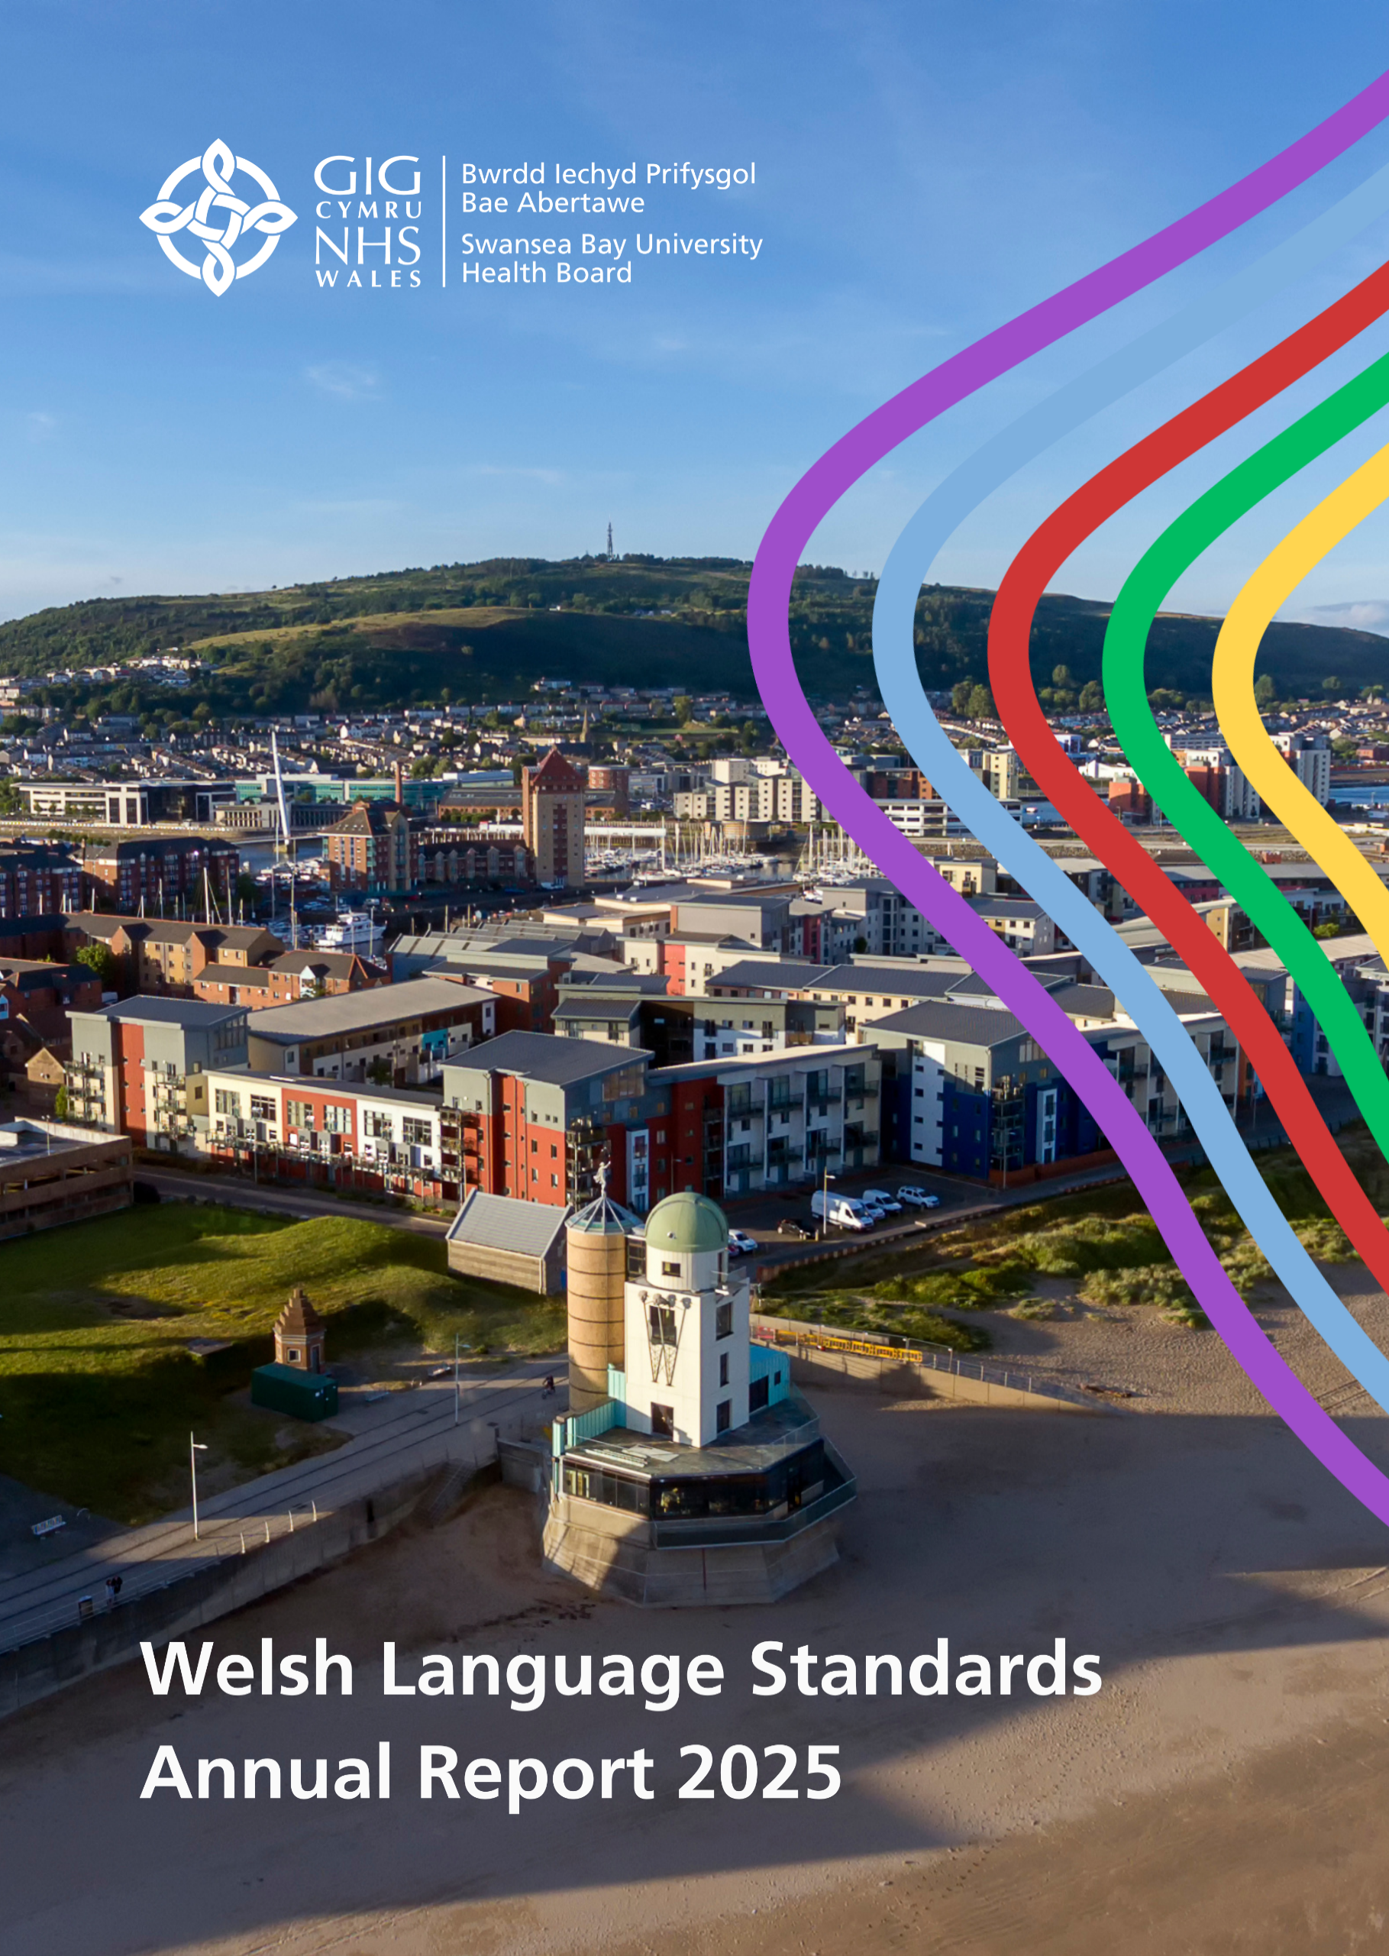

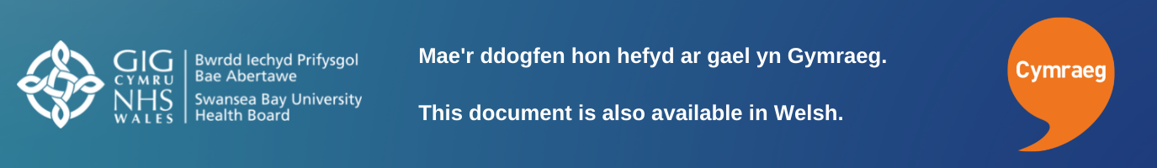
Contents
Chair’s Foreword 4
Introduction 5
Our Duty of Quality 5
Governance and Accountability 5
Support to Deliver 6
Service Delivery 7
Contacting us by telephone or writing to us 7
Website and social media 7
Reception services 8
Primary Care 9
Policy Making Standards 10
Engaging with the public 10
Operational Standards 11
Providing Clinical Consultations in Welsh 11
Using the Welsh language within the organisation 11
Case Example: Cornel Cymraeg 13
Employment Matters 13
Software packages 13
Use of artificial intelligence 14
Intranet 14
Recruitment Administration 15
Opportunities to learn Welsh 16
Case Example: Nurturing a bilingual community 16
Building Partnerships 17
Llais y Lle – Voice of Place 17
Priorities for the coming Year 19
Organisational Operational Priorities 19
Welsh Language Priorities 19
Leadership 19
Governance 19
Communicating with our Patients 20
Bilingual Clinical Provision 20
Developing our staff 20
Understanding our Staff Skills 20
Our Welsh language learning pathway 20
Record Keeping 22
Appendix 1 23
Appendix 2 24
Appendix 3 25
Appendix 4 26
Appendix 5 27
Appendix 6 28

Chair’s Foreword
I am proud to share Swansea Bay University Health Board’s annual Welsh Language report for 1st April 2024 to 31st March 2025 which reflects our ongoing commitment to the Welsh language within our communities and to delivering safe, high-quality, person-centred care to our patients.
Over the past year we have worked to improve our compliance with the Welsh language standards, but perhaps more importantly we have worked to promote the language and opportunities to use it within our services to achieve meaningful and lasting change.
Language is an important element of person-centred care. In health services, it is important that we communicate effectively and respect people’s language needs. Our work to support bilingual health care improves not only patient experience but also can have a positive impact on their outcomes.

I would like to thank our dedicated staff who have shown enthusiasm and commitment to providing Welsh language services for our patients, delivered in the context of increasing demand for our services. This work includes learning new skills, digital changes and considering the needs of Welsh speakers within our services. I would also like to thank our patients for supporting us to achieve this change, through providing us with feedback on where we can improve.
Cymraeg belongs to us all and I look forward to the coming year where we will expand how we promote and use the language in our services.

Jan Williams OBE FRSPH
Chair

Introduction
Swansea Bay University Health Board has a statutory duty under the Welsh Language (Wales) Measure 2011 to produce and publish an annual report on its compliance with standards set by the Welsh Language Commissioner.

This report will evidence how this Health Board has performed in relation to our compliance notice for the reporting period; 1st April 2024 – 31st March 2025. The report also sets out our commitment to the Welsh language and sets out our priorities for the coming year.

Our Duty of Quality
The Duty of Quality describes the need for health boards to provide Welsh language services in people’s first language as an integral part of person-centred care. Within Swansea Bay University Health Board, we recognise the relationship between language and quality, which is why our governance arrangements have been revised to strengthen reporting and accountability for the Welsh language within our systems for managing quality.
This report should be read in conjunction with our Annual Quality Report, where we describe the achievements and priorities in improving the experience and outcomes for Welsh-speakers.

Governance and Accountability
Our Chief Executive is corporately responsible for compliance with the Welsh Language Standards. The Director of Nursing and Patient Experience is responsible at an Executive level and is supported by the Head of Quality and Safety and the Welsh Language Lead in delivery of strategic objectives.

Responsibility for delivery of bilingual services is overseen by our Welsh Language Delivery Group and Quality and Safety Group, which in turn report into the Quality and Safety Committee of the Board. The Welsh Language Delivery Group exists to provide assurance to the Board that systems and processes are in place to enable the organisation to meet its responsibilities under the Welsh Language Measure. This group is chaired by an Executive Director and reports through them to the Quality and Safety Committee, which in turn reports to the Health Board. We acknowledge that the function and membership of this group requires review in order to help us take forward the requirements of More Than Just Words and the Duty of Quality and during the coming year we will revisit and amend this group’s responsibilities.

This report has been complied in line with guidance set out by the Welsh Language Commissioner and has shared with members of the Welsh Language Delivery Group, prior to approval by the Quality and Safety Committee prior to publication.

Support to Deliver
Our Welsh Language Services Team led by the Welsh Language Lead, are now part of the corporate Quality, Safety, and Improvement team, where they can promote Welsh language considerations within our wider quality management system. This includes our quality assurance structures and our improvement support.
The strategic guidance that this team offers to managers and staff across our organisation ensures that, as a body, we are interpreting and implementing the standards appropriately. As a result of this work, throughout this year we have seen continued growth in demand for services offered by the team, namely translation and additional training opportunities.

Service Delivery

Contacting us by telephone or writing to us
We welcome receiving correspondence in Welsh, writing to us in Welsh will not result in a delayed response compared to writing to us in English.
All of our departments and services can respond to correspondence received in Welsh within set organisational time frames. If support is needed, our in-house translation team makes sure we reply on time.
We have continued the work of improving the quality of our phone lines so that callers to our main numbers and departments are now greeted in both Welsh and English. This has been a significant piece of work, but it is important to us that callers are able to have their all answered bilingually. At the time of reporting around 75% of our phone lines now have a bilingual greeting and we aim to make sure that all of our phone lines have a bilingual greeting by April 2026. Having bilingual greetings is important in helping us to understand the demand for Welsh language services, monthly reporting of data has shown that the demand for a Welsh language service is consistent, and our ability to meet that demand is steadily increasing.
Our main switchboard is made up of 22 call handlers (with 1 post vacant at the time of publication of this report). Of these staff, 7 have appropriate Welsh language skills to be able to offer a service to callers in Welsh. We are actively increasing Welsh language capacity within this team as opportunities to do so arise.

Website and social media
Our websites and social media presence are increasingly popular sources of information for our patients and communities. Here people can access information about the wide range of services that we offer. We also use our social media accounts to continually raise awareness of campaigns and activity being carried out by the Health Board with the aim of improving public health.
This Health Board has stand-alone Welsh and English websites, as well as a presence on social media platforms.
- On Facebook, our Welsh account has 194 subscribers. (+6)
  - https://Facebook.com/BaeAbertaweGIG
- On X / Twitter, our Welsh account has 358 followers. (-13)
  - https://x.com/BaeAbertaweGIG
- On Instagram, our Welsh account has 98 followers. (+10)
  - https://www.instagram.com/bipbaeabertawe?igsh=Z3Vsc2M0eDZvd2cy
- On LinkedIn, our Welsh account has 36 subscribers. (+25)
  - https://www.linkedin.com/company/73177598/admin/dashboard/

Reception services
When people come into our hospitals, being able to provide them with a service through the medium of Welsh can help to improve their experience. By understanding the Welsh language skills of our staff, we can plan our workforce to increase these skills where needed. The language skills of our current workforce (at the time of reporting) in our reception areas are as follows: -
Morriston Hospital
16 members of staff cover the reception desk within the Emergency Department (ED). Of these, 1 (6.25%) are Welsh speakers.
10 directly employed staff provide main Outpatients Department reception services, 2 of whom (20%) are Welsh speaking.
Singleton Hospital
17 part-time staff provide reception services for our Outpatients Department at this hospital. None of these staff speak Welsh.
Neath Port Talbot Hospital
11 staff provide reception services on a rota at our Minor Injuries Unit. 1 of them is a Welsh speaker. (9%)
20 staff welcome patients to our main Outpatients department at this hospital. 1 (5%) of them is a Welsh speaker.
Children’s Assessment Unit (inside hospital) 4 staff welcome patients on a rotated basis. None of them are Welsh speakers (0%)
Childrens Centre (outside hospital): 10 staff welcome patients (different services provide reception cover). 3 are Welsh speakers (30%)
NPTH Mental Health: 2 staff welcome patients. None of them are Welsh speakers (0%)
Volunteer Desk: 13 staff welcome patients on a rota. 1 of them is a Welsh speaker (7.69%)
A new training programme will be offered to reception staff over the next twelve months to embed the Active Offer into their practice. This training will also be offered to our volunteer staff, who are often the first point of contact on reaching our hospitals.
Our recruitment strategy requires managers to consider the need for Welsh language skills when advertising vacant positions. An assessment of linguistic ability within the team is a factor in reaching a determination around skill need. Our aim is to increase the number of Welsh speakers in these roles; however, this is a longer-term ambition as staff turnover is low in these roles. This is why our Welsh language learning pathways for non-Welsh speaking staff are so important.

Primary Care
We support our colleagues in Primary Care to carry out the six duties imposed on them by the Welsh Language Commissioner, namely:
- Notification of Welsh Language Services: Contractors must notify us in writing when they are able to provide services in Welsh.
- Provision of Welsh Language Documents: All documents or forms provided must be available in Welsh alongside English.
- Bilingual Signs and Notices: New signs or notices must include text in both Welsh and English.
- Use of Welsh Language Badges: Staff providing services in Welsh should wear badges to indicate their Welsh language skills.
- Awareness and Training: Staff are encouraged to access information and attend training courses to promote Welsh language awareness.
- Encouragement of Staff Participation: Contractors must encourage staff to participate in training and events to enhance their Welsh language

We regularly circulate information to the sector to raise awareness of these obligations and continue to offer support in promoting any services that they can offer.

The translation service we offer to the Primary Care sector in order to meet their obligations is currently offered without charge.

Policy Making Standards
During this reporting period, we have reviewed our processes for assessing the impact of decision making and have ensured that the Welsh language is embedded in this work.

Understanding how any changes we might make have an impact (positive or negative) on the Welsh language and its speakers is important. Considerations regarding the Welsh language are included in our processes for assessing the impact of our decisions and where there is potential negative impact, we work together to address this. When we develop new policies our Stakeholder Reference Group review them before they are agreed, at least one member of this group needs to be a designated champion for the language to ensure that the group’s scrutiny includes language considerations.

Here at Swansea Bay, we see the Welsh language as being a core element of our Quality Strategy. This strategy acknowledges the importance of the Welsh language in providing high quality care to our patients and communities and gives a commitment to supporting the organisation in meeting our responsibilities under the Welsh Language Standards.

Our latest annual quality report includes examples of progress against the More Than Just Words framework and highlights the work happening to increase our ability to offer clinical consultations in Welsh.

We are already seeing a greater appreciation across not just our organisation, but across the wider healthcare sector of the importance of language as a fundamental component of delivering safe, high-quality care.

Engaging with the public
When undertaking consultation with the public, we have ensured that all documentation has been made available in Welsh and distributed along with English versions. This has meant that those documents have been readily available to Welsh speaking members of our community without them having to make a request.

Our commitment to improving the experiences of Welsh speaking service users as well as our process for considering the impact decisions taken could have on the language is always outlined in our consultation documents. Whilst we provide these documents in text format, we are also able to provide them in braille and audio formats in Welsh if required.

We recognise that the availability of Welsh versions of documents is only part of the way that we need to engage with Welsh speakers in our communities. Our Department for Insight, Communication and Engagement have included considerations around the Welsh language into their workplan. As we look forward to the coming year, we will look to undertaking listening exercises with Welsh speakers in order to understand their experience of our care.

Operational Standards

Providing Clinical Consultations in Welsh
Being able to speak to a clinician in Welsh not only helps people to understand their condition and plan of care, but it also means that clinicians can better understand their needs and how to meet them.
In December of 2024 we published our 5-year plan which details the actions we will take over the next five years to increase our ability to deliver clinical consultations in Welsh. This piece of work was developed over 18 months prior to publication and our efforts in this area over the next five years will focus on services in the key priority areas listed in More Than Just Words, namely,
- Mental Health, Learning Disabilities and Dementia Care
- Speech and Language Therapy
- Stroke Services
- Care of the Elderly
- Children and Young People’s Services.
In the short period since publication, managers in those areas have already been able to report progress. A significant increase in staff recording their Welsh language abilities has been evidenced in Mental Health and Learning Disabilities, enabling managers to identify staff to take part in courses aimed at boosting confidence and upskilling. Whilst in Speech and Language therapy great strides have been taken in recruiting volunteer ‘anogwyr’ to encourage more of our staff to give Welsh a go and make a commitment to delivering the Active Offer.
Progress on this piece of work is monitored quarterly by a newly established working group which reports to the Welsh Language Delivery Group.

Using the Welsh language within the organisation
The use of Welsh within our health board is not limited to when we are communicating with patients or our communities. We have Welsh speaking members of staff; as part of our We Belong, equalities strategy, it is important to respect their language needs as well as encouraging others to learn.
We have a policy in place that describes the organisation’s responsibilities with regard use of the language throughout our internal operations. This policy aids staff in remaining compliant with the Welsh Language Standards and helps in promoting the use of Welsh across our organisation. Along with pages on our staff intranet site, this policy offers practical advice and guidance to all staff to be able to use more Welsh at work.
To further support this aim, over the past 12 months we have been appointing staff as volunteer ‘Anogwyr’ (encouragers) of the Welsh language. This role is still in its infancy, and we are excited to see how it will evolve. The fundamental principle is that these staff members will be there to spur on all members of staff to use the Welsh skills that they have as well as signposting team members to opportunities to upskill.
Case Example: Boosting the Use of Welsh in Occupational Therapy
As a first language Welsh speaker, it is important that I support and encourage individuals to use Welsh. I use the language in my work and can testify to the importance of language in the health and care of patients.
Lisa Gallagher-Evans

Following a successful 6-session pilot project to raise the confidence of occupational therapy staff in the health board, a Welsh Language Occupational Therapy (OT) group was set up to support Welsh speakers and learners within the Health Board Occupational Therapy service to use their Welsh language skills in a work environment.
Lisa Gallagher-Evans and Thomas Williams (occupational therapists) work together to organise and facilitate the monthly sessions, which provide Occupational Therapy (OT) staff with the opportunity to network with other Welsh speaking colleagues and discuss OT-specific themes through the medium of Welsh, boosting use, confidence, and proficiency among the OT workforce.
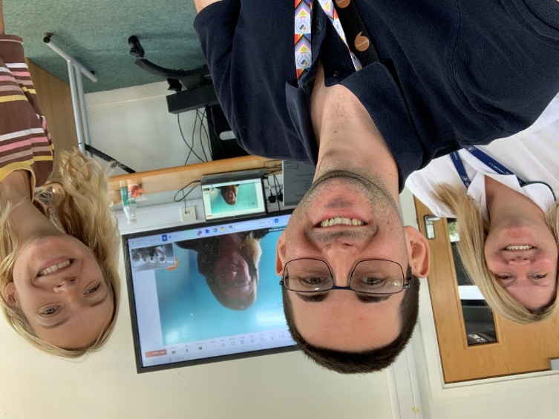
Lisa and Thomas both attended national Welsh Language workshops, which sparked ideas for how to structure the group, and plan to incorporate group members' preferences into session plans as the group develops. Group attendees value the dedicated space to speak Welsh and have noticed improved confidence after just one session.
As a Welshman that has learnt Welsh as an adult, it is essential to me that I use my Welsh as much as possible. We are very lucky that our Senior Leadership Team support us, and personally, i have built on what i have learnt through the confidence raising course led by the Health Board’s Welsh tutor, to help my colleagues develop their language skills too.
Thomas Williams

Thomas and Lisa with their OT colleagues
New staff joining the Health Board and OT students will be encouraged to join the monthly sessions, fostering a sustainable network of Welsh-speaking OT staff in a culture of “always improving.”

Case Example: Cornel Cymraeg
Established in 2022, Cornel Cymraeg is a weekly virtual gathering of staff who wish to use their Welsh. The sessions are open to all staff, Welsh speakers, learners, and those that just want to hear the language spoken.
Our motivation in establishing these sessions was to offer staff a safe space to practice and refine their Welsh language skills, with a view to increasing its use with patients.
The sessions are held at varying times on varying days so that all staff have an opportunity to attend. We are fortunate that they are well attended. We hope to expand this provision over the next 12 months to include face to face sessions and possible thematic days out to reinforce the importance of strengthening Welsh skills.

Employment Matters
A proportion of our staff speak Welsh and Swansea Bay University Health Board automatically issue all its contracts of employment to staff bilingually.

We use the national Electronic Staff Record (ESR) system to process annual leave and absence reporting. Due to linguistic limitations of the platform, it is not possible for us to implement these processes in Welsh at present. This is an issue that is not unique to us here at Swansea Bay and our partners at Digital Health Care Wales (DHCW) and NHS Wales Shared Services Partnership (NWSSP) continue to push for improvements to the system at a UK level. A replacement for ESR is currently in the very early stages of development and representations are being made to ensure that the replacement platform will perform as required.

As an employer we want people to be able to staff can engage with us in the language that they are most comfortable using. This includes throughout our recruitment processes, where staff can apply for jobs with us in Welsh and request that interviews are conducted in Welsh.

We manage the process of recording and supporting staff through sickness absence at a line manager level. To support Welsh speakers, all paperwork associated with this procedure is available to staff in both English and Welsh.

Software packages
We offer all our staff the option of installing software on their computer systems which will support them in using their Welsh language skills in their work. The software packages approved for use on our networks are:

Cysgliad – This suite of programmes offers a Welsh to English and English to Welsh dictionary, as well as a spelling and grammar check function.

To Bach – This programme, once installed, allows the user to access special characters used frequently in Welsh by means of a simple shortcut key stroke.

Microsoft 365 Interface - Microsoft offer a Welsh language interface for their 365 suite of programmes. Staff can access and apply this interface through their personal user settings.

Our in-house translation team use translation memory software in their work. We are seeing a slow but steady growth in the size of key terms and phrases stored in our local memory, which is in turn increasing capacity within the team.

We regularly monitor the market for new applications or websites which could support our staff in using their Welsh language skills in the workplace.

Use of artificial intelligence
For quality assurance purposes, the use of artificial intelligence to translate correspondence by non-Welsh speakers is not currently permitted. This emerging and fast-developing technology has the potential to transform how we use tech to increase capacity within our translation service; however, it is essential that the user had a sound knowledge of Welsh so that any nuances or context can be appreciated during the translation process. Our Welsh Language Services Department are closely monitoring developments in this area.
Email is the most common method of communication used by those writing to us, and with this in mind, during 2023 we introduced partial Welsh email addresses to our most heavily used email address. We have now expanded this approach so that all new public-facing email addresses are available in Welsh and English. Preexisting email addresses are translated and activated as they are presented to our translation team.
Our partners at DHCW are currently considering methods to introduce a Welsh language domain for the NHS in Wales. Swansea Bay UHB have agreed to take part in a pilot project to test functionality and identify potential issues prior to ‘@gig.cymru’ being introduced nationwide. Whilst there is no set date for national introduction of the Welsh language domain, it is anticipated that SBU will start testing towards the end of 2025.

Intranet
We want to make it as easy as possible for our staff to find information on the language and our responsibilities with regards to it. A wealth of resources to support staff in using Welsh at work can be found on the Health Board’s intranet site.
Under the help and guidance section, staff can access information relating to how we maintain compliance with the Welsh language standards with detailed information on processes ranging from ‘Responding to Correspondence’ and ‘Using Social Media,’ through to ‘Conducting Meetings’ and ‘Workforce Planning.’ The content on these pages is kept under constant review to ensure that the advice being provided to staff is making Cymraeg as accessible as possible.

Through other pages linked from this homepage, staff can:
- access resources such as bilingual posters encouraging patients and visitors to use Welsh with us,
- order Iaith Gwaith badges and Lanyards.
- access frequently translated job titles, departments and addresses as well as a directory of email addresses and their Welsh equivalent aliases.
The content available to staff through this site is constantly growing, so that staff can access the information they need, when they need it.

Recruitment Administration
We are proud to report that during this reporting period; we have significantly increased the level of assurance that we can offer in relation to standards connected to advertising and recruiting to vacant posts.
The Welsh language standards require us to publish adverts, job descriptions and all other related documents in Welsh as well as English. Whilst at the beginning of the reporting period we were achieving this with many posts, we recognised that there was much room for improvement. We developed a robust action plan with support from the Welsh Language Commissioner’s team and completed all actions by December 2024.
As part of this process, all standardised job descriptions have been translated and are stored in a central library. Any new or reviewed job descriptions are processed by our job evaluation team and translation of these documents is completed before they are released to the managers. We have also adopted bilingual documents as the organisational standard for job descriptions, so that the English version cannot be distributed without the Welsh.
NWSSP publish job adverts to TRAC and NHS Jobs on our behalf. From November 2024, stringent processes were introduced, and authority was given by this Health Board for them to reject any vacancy advertisement requests for Agenda for Change posts that did not fully meet the requirements of the Welsh language standards. Through engaging with managers and raising awareness in advance of this instruction only small numbers of posts have been rejected since this new process was introduced. Given that we recruit into around 2000 posts per year, this has been seen as a significant achievement.
Our commitment to fully comply with these standards has had a significant impact on our in-house translation service. In January 2025, the service experienced a 512% increase in the number of words sent to us for translation when compared with January 2024. Our team have risen to the challenge and with the support of contracted external translation services, have been able to maintain agreed service levels.

Opportunities to learn Welsh
If we are to increase the opportunities for patients to use Welsh, it is important that our workforce have the skills to do this. To help us achieve this we offer various opportunities for people to learn Welsh or to improve their confidence in the language.
We have a positive working relationship with both the local and national centres for learning Welsh. Across our workforce we currently have around 40 members of staff enrolled on long form courses. This year, we have seen one group of learners progress from entry level to foundation; our learner groups at our hospital sites will progress to foundation in September.
Additionally, we are also offering confidence raising courses. These are aimed at staff who have a good understanding of the language but might not have the confidence to use it. These staff members may have been educated through the medium of Welsh, learnt Welsh as an adult up to Intermediate level, or come from a Welsh speaking home. Whatever their reason for not using Welsh, these specially tailored courses are designed to help staff to be confident in their ability and to overcome any barriers to ‘having a go’ at using their skills with colleagues and patients.
With support from the National Centre for Learning Welsh, we have also started offering ‘Welcome Welsh’ courses. These courses are aimed at staff that have told us they have no Welsh language skills. The course introduces staff to some very basic words and phrases that they can start using with patients and colleagues straight away and it is hoped that this opportunity will spark an interest in many to continue their Welsh language journey.

Case Example: Nurturing a bilingual community
Our Occupational Health, Speech and Language, and Mental Health teams have established groups of Welsh language champions that promote and encourage the use of Welsh at a micro level across the organisation.
The staff that have taken on this role are working to raise awareness of the importance of being able to interact with our patients and visitors through the medium of Welsh. The peer support that they offer includes informal sessions to chat and practice Welsh, the sharing of profiles so that colleagues know who they can approach for support, as well as Welsh activities during lunch and learn sessions.
This project will be developed further into the future, with formal training and support offered to those taking on this voluntary role.

Building Partnerships
Working with others will help us to achieve our aims. This includes working with other NHS bodies and partners outside of health services.
Our Welsh Language Lead continues to sit on and contribute to the All-Wales strategic group for the Welsh language. This group is made up of Welsh Language managers from healthcare organisations in Wales. Collaborative working and sharing best practice were the aims of this group at its inception, but as it has developed and it has been able to make formal all-Wales representations to Welsh Government and the Welsh Language Commissioner on matters concerning the Welsh language in healthcare.
Our Welsh Language Lead also regularly meets with Welsh Government to report and receive feedback on progress with ‘More Than Just Words’ and other matters affecting the Welsh language agenda.
Swansea Bay are excited to be leading on the NHS Wales presence at the 2025 Urdd Eisteddfod at Margam Park. This will be the first time that multiple NHS organisations have come together under one banner to engage with the public at these events. It is anticipated that this collaborative presence will also be replicated for the National Eisteddfod at Wrexham in August of 2025. A full review of this engagement activity will feature in our report for the next reporting period.

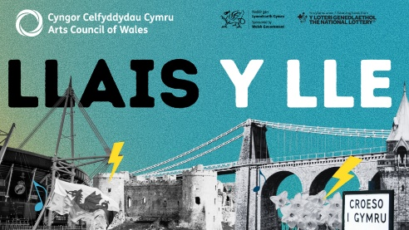
Llais y Lle – Voice of Place

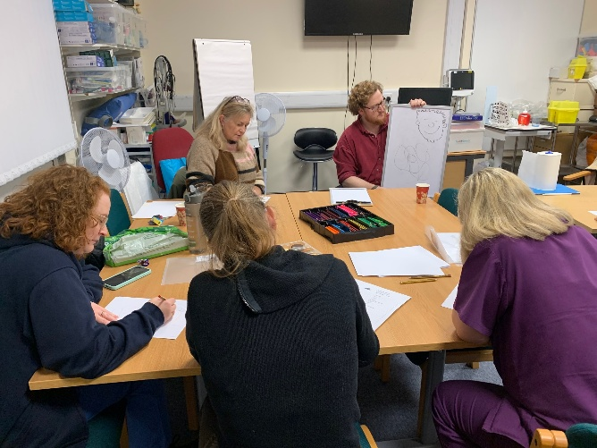
Through partnership working, we were successful in attracting funding from the Llais y Lle fund of the Arts Council of Wales this year. This funding has enabled us to develop opportunities for our staff c who are learning Welsh to experience the contemporary creative culture of Wales.
Throughout the year, we have welcomed guest artists to work with our staff who learn Welsh, so that they can put into practice the skills they learn during their lessons in a safe environment without judgement.
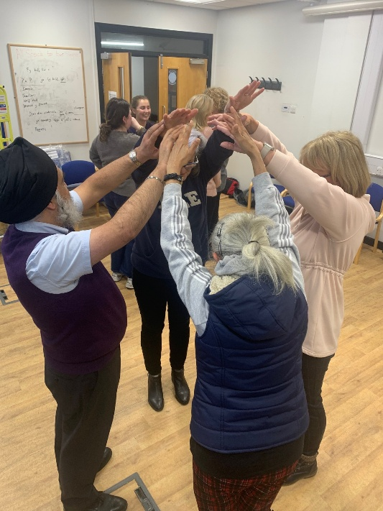
The sessions vary greatly, and so far, the staff have experienced opportunities to undertake composition and rapping workshops with bard Aneirin Karadog, improvisation and characterization with Anwen Carslile and a caricature session with Sion Tomos Owen.

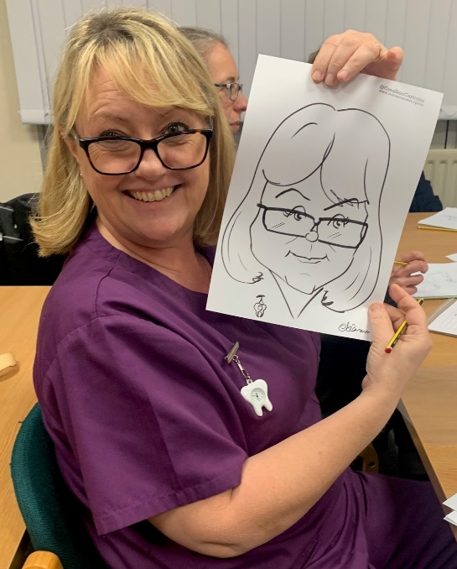

We will fully assess the success of the project after it has finished later in the year, but so far, the feedback from the staff has been extremely positive with many noting that the sessions have given them the opportunity to use their Welsh in a creative, supportive atmosphere.



Priorities for the coming Year

Organisational Operational Priorities
Our responsibilities towards the Welsh language and its speakers cut-across all of our organisational priorities. For this reason, guidance on assessing the impact on the language is included in our Integrated Medium-Term Plan (IMTP) guidance.
We recognise that we need to strengthen how Welsh is considered in our organisational priorities and will be working with colleagues to ensure that the language is considered in our quality improvement work within
- unscheduled care
- planned care
- maternity
- mental health and learning disabilities

Welsh Language Priorities
The following priorities have been developed to support us in making a measurable difference in providing bilingual care for our patients and in supporting staff to develop and use their Welsh language skills.

Leadership

Board Development Sessions
As a diverse organisation which employs in the region of 20,000 staff who serve a population of around 380,000 it is important that those charting our course are as fluent in our responsibilities around the language as those welcoming patients through our front doors.
We will work with colleagues to ensure that our Board is given an opportunity to learn some Welsh and engage meaningfully in the conversation around enhancing our Welsh language offer to patients.

Executive Development Sessions
Building on the sessions delivered to the Board, we will provide a similar opportunity to our Executive Team so that a commitment to the language and its speakers is embedded at the senior level of the organisation.

Governance

As noted previously within this report, the structure and function of the Welsh Language Delivery Group will be reviewed. Alongside this work, we will review our reporting arrangements and how we maximise digital technology to plot our progress against the Welsh Language standards.

Communicating with our Patients

Bilingual Clinical Provision
As part of our work around Standard 110 which requires us to develop five-year plans to deliver bilingual clinical consultations for the patient groups prioritised in the More Than Just Words framework, services are developing individual plans to progress this work. These plans will be published as updates to our over-arching plan in December 2025.
Managers will consider how certain aspects of their provision could be reconfigured, using intelligent rostering, promotion, and patient allocation to ensure that Welsh speaking staff are in the right place to be able to offer appropriate service to patients that need their care in Welsh. Some provisions that are being considered as areas for transformation are speech clinics and mental health drop-in workshops, however this feasibility work is still ongoing.

Developing our staff

Understanding our Staff Skills
We’ve continued to make steady progress in collecting data on staff Welsh language ability over the past year, but there is still a way to go until we reach a point where we could consider ourselves able to offer a high level of assurance in this area. Since our last report, we have been able to increase the number of records we hold on our staff’s language skills by about 8%.
Following recent discussions within the Executive Team, we are hopeful to be able to make a significant change to this position during the coming year, through mandating the recording of language competency on the ESR system.

Our Welsh language learning pathway

A significant number of our staff have expressed interest in learning Welsh from a beginner level. This is something that we are really proud of, and we are committed to working with the National Centre for Learning Welsh to ensure that there is a clear pathway for staff of all skill levels to reach proficiency in Welsh.
We must however ensure that any resource allocated to our Health Board for advancing Welsh language abilities is used effectively. Over recent years, we have witnessed some staff members embarking on courses but for various reasons, not being able to complete them. This means that due to the limited number of places available, that potentially, somebody that could have completed the course has missed out.
We will be working with our allocated full-time tutor to consider how best to tackle this issue, ensuring that everybody that expresses an interest gets to undertake some learning, and that those who are willing to commit to a long-form course receive support from their line management and the Health Board’s Welsh Language Services Team to achieve their ambitions.
Into the future, Welsh language learning will be considered part of the Continuous Professional Development of staff and as such, it is vital that learning and using Welsh becomes an embedded component of Performance and Development Review (PADR) discussions. Managers, where possible should be encouraged to release staff from their duties to further their Welsh learning, as they would with any other professional study.
We will also enhance our offering for established Welsh speaking staff. Providing them with easily accessible opportunities to polish their skills. This may include releasing staff to attend residential provisions offered at Nant Gwrtheyrn.
In this regard, aftercare and social engagement opportunities will be vital to reinforce learning and provide staff with the opportunity to put learning into practice. Our Welsh language services team will develop further this offering over the coming year, working with community-based partner organisations.

Record Keeping

Appendix 1
Record of New and Vacant Posts

Appendix 2
Welsh Language Staff Competency

Appendix 3
Complaints

Appendix 4
The Welsh language in Swansea and Neath Port Talbot

Appendix 5
Patient Experience – Survey Feedback

Appendix 6
Overall Compliance - Snapshot

Appendix 1
Record of New and Vacant Posts
Recruitment
Statistics relating to the Welsh language status/requirements for jobs advertised by the Health Board during 2024/25 are set out below. For the third consecutive year, we have seen a significant decrease in the number of posts advertised as ‘Welsh Not Required’, down to 30 posts this year from 54 last year.
We continue to keep our bilingual skills strategy under review, emphasising the need to ensure that the Welsh language requirements of all vacancies are robustly assessed prior to any advertisements being placed. This will help to ensure the development of a workforce with the capacity to deliver care and services in the recipient’s preferred language.

Posts advertised by us between 01 April 2024 and 31 March 2025.

During this period, 1,722 posts were advertised by our Health Board. The Welsh language skills requirements of those posts were assessed as follows:

- Welsh language skills are Essential – 4 Posts advertised.
- Welsh language skills are Desirable – 1,688 posts advertised.
- Welsh language must be learnt on appointment – No posts advertised in this category.
- Welsh language skills are not required – 30 posts advertised.

We are fortunate to have the use of the TRAC website and also NHS Jobs which enables us to promote and administer posts through the medium of Welsh. Both gateways enable applicants to submit applications in Welsh, and all communication with the applicant is bilingual. Applications submitted to us in Welsh are given priority by our translation team, so that managers can score the application within a specified time frame. The electronic application form asks the applicant if they wish any interview to be conducted in Welsh, and we have a process in place to enable this to happen.

Appendix 2
Welsh Language Awareness
At the end of the reporting period, 91.99% of our workforce have undertaken the ‘More than Just Words – Welsh language awareness’ training. Our organisational target for compliance is 85%

Staff Welsh Language Competency
As one of the region’s largest employers, we employ 22,850 members of staff. This figure includes permanent, locum and bank staff. On the last day of March 2025, 13,445 (58.8%) of those staff members had recorded at least one language competency through the National ESR system. On the same day, 9, 405 members of staff had not yet recorded their language competencies.

Breakdown of Welsh language skills of our workforce
The following percentages are based on the staff members who have recorded their language skills with us.
Speaking
595 Members of staff have told us that they have speaking and listening skills at Level 5 (4.51%), whilst 533 members of staff felt that their skills were at a level 4 (4.04%).
Fewer staff recorded their skill levels at level 3. 411 Recorded their skill at this level (3.12%). 522 noted their skill at level 2 (3.96%).
The numbers increase significantly when looking at levels 1 and 0. 1,979 recorded their skill at level 1 (15.02%) and 9,130 recorded level 0 (69.32%).
Reading
Of those who have responded, 609 recorded their reading skill level at level 5 (4.59%), and 515 recorded their reading skill at level 4 (3.88%).
The figure reduces when we look at level 3, with 324 (2.44%) recording this level. 532 staff members recorded their skill at level 2 (4.01%).
Again, the numbers increase significantly when looking at levels 1 and 0, with 1,667 members of staff recording reading skills at level 1 (12.57%), and 9,609 recording a reading skill level at level 0 (72.48%).

Writing
519 members of staff told us they could write in Welsh to Level 5 (4.10%). This figure reduces to 386 when we look at the responses to level 4 (2.81%).
358 members of staff have recorded their writing skill at level 3 (2.82%) and 566 noted skills at level 2 (4.47%).
The pattern of the numbers increasing significantly continues when we look at reading skills at levels 1 and 0. 1,405 members of staff told us their writing skills in Welsh are at level 1 (11.10%) and 9,939 recorded their skills at level 0 (78.54%).

Summary of Welsh language competency at levels 4 and/or 5
Number of staff who have told us that they have Welsh language skills at levels 4 or 5:
- Speaking and listening, 1128 members of staff.
- Reading, 1124 members of staff.
- Writing, 905 members of staff.

Appendix 3
Complaints
Details of the Health Board’s complaint procedure, including complaints relating to our compliance with the Welsh Language Standards, are published on our website in line with the requirements of our compliance notice.
During this reporting period, our complaints team have not received any complaints relating to a possible breach of the Welsh Language Standards.
Our Patient Experience team have not received any complaints, concerns or enquiries relating to our Welsh language provision during the reporting period.

Appendix 4

Cymraeg in the Community
The number of people who can speak, read, and write in Welsh is captured as part of the national census. The results of the 2021 census were released last year and data for the communities we serve is shown here.

City and County of Swansea
11.20% of Swansea’s population over the age of 3 can speak Welsh. 8.60% of residents over the age of 3 can speak, read, and write in Welsh.

Neath Port Talbot County Borough
13.50% of residents in Neath Port Talbot over the age of 3 can speak Welsh. 10.20% of residents over the age of 3 can speak, read, and write in Welsh.

Swansea Bay Region
The Health Board’s area incorporates both counties mentioned above.
12.06% of the residents of our region over the age of 3 can speak Welsh.
9.20% of the residents of this region over the age of 3 can speak, read, and write in Welsh.

Office of National Statistics (ONS) data
We use ONS data to guide our ambitions in developing a bilingual workforce. We are aiming to demonstrate a greater correlation between the two data sources as we develop the skills of our current workforce and recruit more Welsh speakers into key roles.

Appendix 5

Patient/Service User Experience
Survey Feedback

During the reporting year, we asked the following question to 15, 173 respondents:

Were you able to speak with staff in Welsh if you needed to?

The question was not applicable to 12,752 (84.04%) of the respondents. The following data is based on the responses of the 2,421 (15.9%) respondents to whom the question was applicable.

64.8% of respondents answered that they were “Always” able to speak in Welsh with a staff member.
11.73% of respondents answered that they were “Usually” able to speak in Welsh with a staff member.
9.29% of respondents answered that they were “Sometimes” able to speak in Welsh with a staff member.
14.16% of respondents answered that they were “Never” able to speak in Welsh with a staff member.

Appendix 6
Overall Compliance
We keep an assurance rating document which is an active record of our ability to comply with the Welsh language standards. This document measures performance in areas relevant to the standards and lists barriers to full compliance. These ratings are based on internal monitoring and reporting, along with patient feedback. Where compliance assurance is listed as medium or low, steps are outlined which detail how the organisation is working to bring itself closer to compliance.
Where assurance is listed as green, monitoring processes are listed to ensure that compliance is maintained.

Snapshot of assurance levels at end of reporting year.

This chart shows that 59% of the standards imposed on us are rating green, or with a “high level” assurance rating, with 29% in the amber “medium level” rating. 12% are rated as having a “low level” rating.


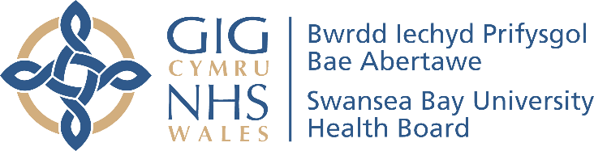

Report Author: Jordan Morgan-Hughes
Date of Publication: 30 September 2025

You may direct questions relating to this report to:
Welsh Language Services Department
Swansea Bay University Health Board
Headquarters
1 Talbot Gateway
Baglan
SA12 7BR

SBU.Cymraeg@wales.nhs.uk

Duty of Quality Statutory Guidance 2023 and Quality Standards, Welsh Government

